$1,500.00
MURRAY – BAKER
4001 NORTH AVE. JAVA
JAVA HELMS 2ND ADDN OUTLOT 3
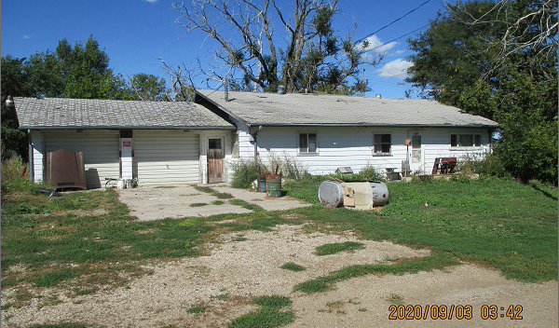
RECORD #4187

LOT SIZE 300’ X 116’ TOTAL LIVING 1344 SQ FT
SINGLE FAMILY – ONE STORY 3 BEDROOMS
VERY BAD CONDITION CELLAR IN BAD SHAPE
NO RECENT RENOVATIONS ATTACHED GARAGE 728 SQ FT
NEEDS LOTS OF WORK OTHER BUILDINGS IN BAD SHAPE
BUILT IN 1950
SOLD ON 8/07/2020 FOR $1,500
ASSESSED IN 2019 AT $11,525
ASSESSED IN 2015 AT $10,480 RECORD #4187

