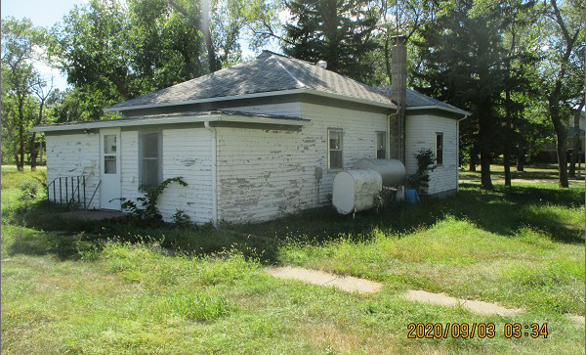
$3,000.00
DUNWOODY – MANAFORT
1200 HELM ST. JAVA
JAVA HELMS 1ST ADDN LOT 1 & N 30’ OF LOT 2 BLOCK 1
RECORD #4172
LOT SIZES 100’ X 210’ DETACHED GARAGE 640 SQ FT
&30’ X 210’ SOLD ON 7/29/20 FOR $3,000
SINGLE FAMILY & ONE STORY ASSESSED IN 2019 AT $6,714
BUILT IN 1900 SOLD ON 3/30/18 FOR $15,000
POOR CONDITION, FOUNDATION FAILING ASSESSED IN 2012 AT $5,669
900 SQ FT LIVING AREA
2 BEDROOMS – BATH RECORD #4172
