$5,000.00
KVASNICKA – BENNS
7406 MINNEAPOLIS ST. JAVA
JAVA MILW LAND CO’S 2ND ADDN LOTS 7 THRU 10 BLOCK 16
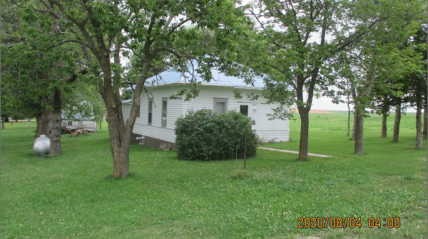
RECORD #4096

LOT SIZE 150’ X 140’ GROUND FLOOR 788 SQ FT
SINGLE FAMILY – 1 STORY 1 BATH 6 FIXTURES
LOW QUALITY & CONDITION ROOFED PORCH 48 SQ FT
YEAR BUILT 1910
2006; INTERIOR PAINT, NEW FURNACE
NEW HOT WATER HEATER
SOLD ON 7/13/20 FOR $5,000
ASSESSED IN 2020 AT $7,220
SOLD ON 10/29/09 FOR $7,900
ASSESSED IN 2009 AT $4,710
SOLD ON 6/28/04 FOR $3,000 RECORD #4096

