$90,000.00
HARDIN – HEIER
211 MAIN ST. AKASKA
AKASKA ORIGINAL LOTS 5 & 6 BLOCK 13
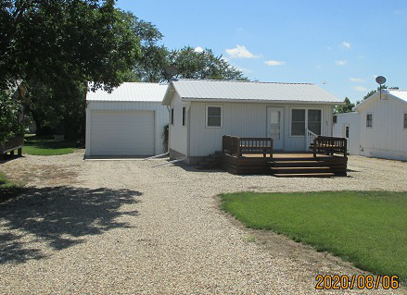
RECORD #3877

LOT SIZE 48’ X 125’ LIVING AREA 480 SQ FT
SINGLE FAMILY – 1 STORY 1 BEDROOM 1 BATH
AVERAGE QUALITY & CONDITION GARAGE 30’ X 30’
BUILT IN 1940 WINDOW AIR
GARAGE BUILT IN 1997 WOOD DECK 16’ X 12’

RECORD #3877

