$295,000.00
SELZLER – BINGER
1410 4TH AVE EAST, MOBRIDGE
N2S2N2SW4NW4
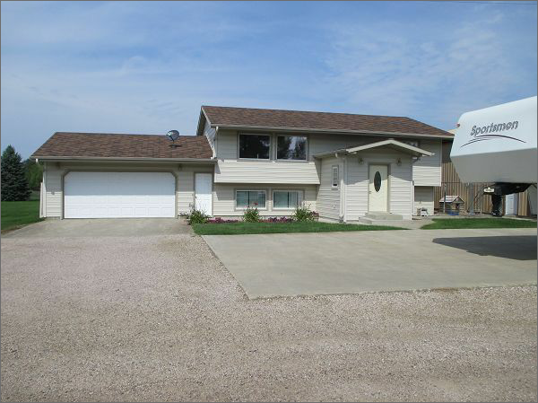
RECORD #3576

LOT SIZE 5 ACRES SPLIT LEVEL ABOVE 974 SQ FT
SINGLE FAMILY – 1 STORY LOWER LEVEL 912 SQ FT
AVERAGE QUALITY & CONDITION 550 SQ FT FIN. LIVING BELOW
BUILT IN 1975 2 BEDROOMS ABOVE 2 BELOW
2015; ROOF GOOD, SPLIT LEVEL 1 BATH ABOVE 1 BELOW
METAL SIDING, VINYL WINDOWS ATTACHED GARAGE 676 SQ FT
CENTRAL AIR, PROPANE FURNACE STORAGE SHED 42’ X 56’
SOLD ON 7/17/20 FOR $295,000 DETACHED GARAGE 34’ X 40’
ASSESSED IN 2020 AT $163,510 WOOD DECK 16’ X 22’
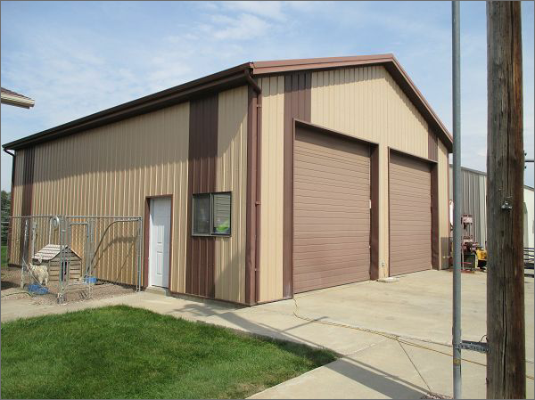
SOLD ON 6/22/01 FOR $125,000 SOLID WALL PORCH 10’ X 12’
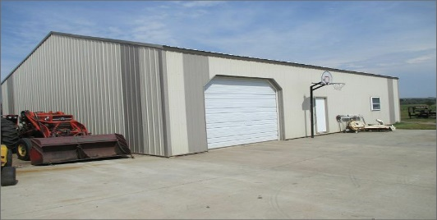
ASSESSED IN 2012 AT $100,505 RECORD # 3576

