$249,000.00
GRISMER/HARTMAN – WUDEL
3908 MARIN DRIVE, SELBY
SELBY OVERHOLSER’S ADDN LOT 14 & S 67’ OF LOT 15
TRACT 1 OF OUTLOT A & TRACT 2 OUTLOT A LOT 7 EXC. S 178’
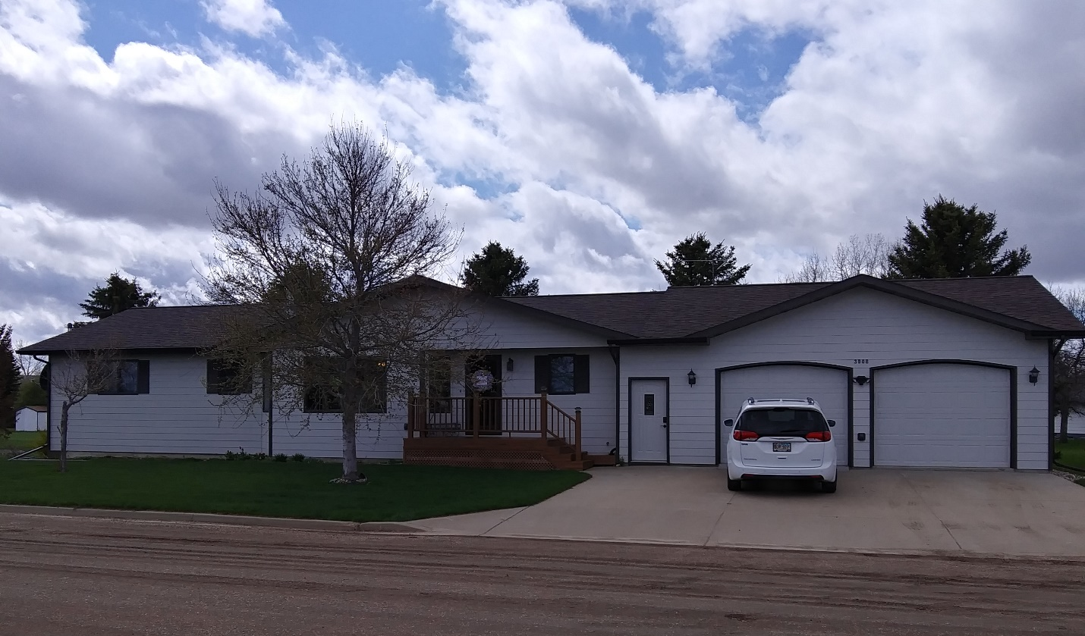
RECORD #8049 & #7675

TRACT 1; 167’ X 100.3’ GROUND FLOOR 1794 SQ FT
TRACT 2; 106’ X 366’ & 28’X56’ 1794 SQ FT FIN. BASEMENT
ONE STORY – SINGLE FAMILY 2 BEDROOMS UP, 2 DOWN
AVERAGE QUALITY & CONDITION 4 ½ BATHS
BUILT IN 2003 2 STALL GARAGE 1024 SQ FT
2015; CEMENT BOARD, METAL/METAL REAR DECK 144 SQ FT
CENTRAL AIR, LARGE BSMT WINDOW 20’ X 24’ STORAGE BLDG.
2003; NEW HOME $160,000, BSMT $70,000 GARAGE IS FINISHED
GARAGE $90,000
SOLD ON 1/3/20 FOR $249,900
ASSESSED IN 2019 AT $241,000
ASSESSED IN 2015 AT $183,785 RECORD #7675

