$30,000.00
DURBIN – QUENZER
317 MAIN STREET, MOBRIDGE
MOBRIDGE ORIGINAL LOT 4 BLOCK 3
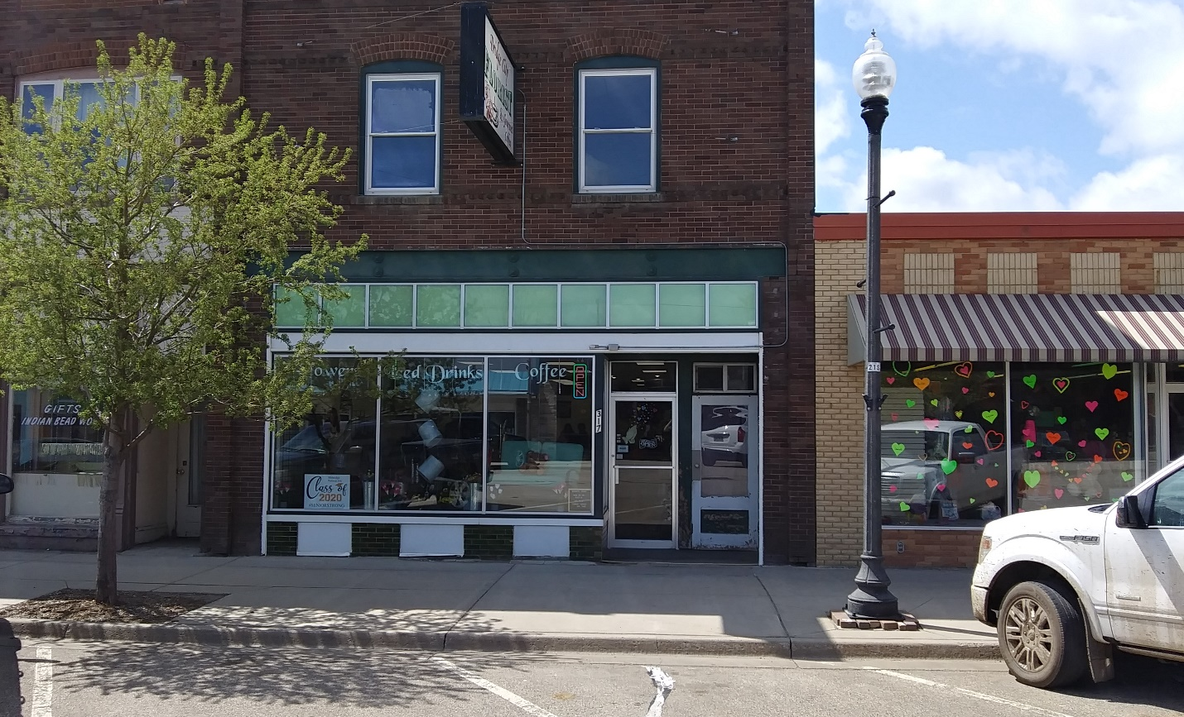
RECORD #6244

LOT SIZE 25’ X 140’ TOTAL SQ FT 4000
50% RETAIL 50% RESIDENTIAL GROUND 2000 SQ FT
TWO STORY 2ND STORY 2000 SQ FT
AVERAGE QUALITY & CONDITION 1 – 2 BEDROOM APT.
YEAR BUILT 1920 1 – 1 BEDROOM APT.
HOT WATER HEAT/PACKAGE AIR BASEMENT 2000 SQ FT
SOLD ON 1/17/2020 FOR $30,000 ALL STORAGE IN BSMT
ASSESSED IN 2020 AT $46,960
SOLD IN 2015 FOR $35,000
SOLD IN 2008 $130,000
ASSESSED IN 2012 AT $40,835 RECORD #6244

