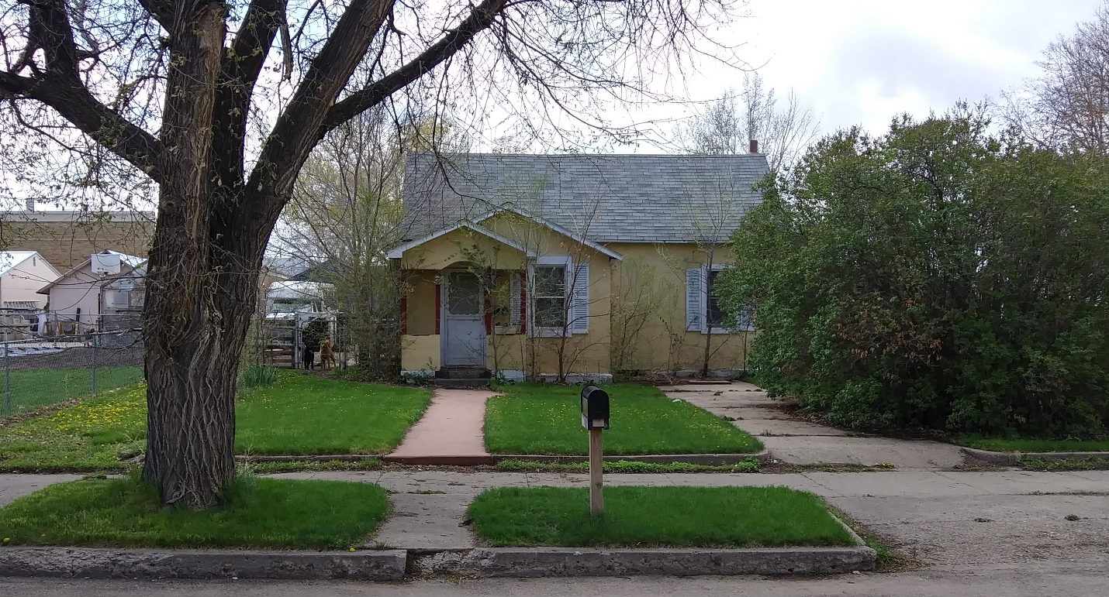
$25,000.00
STEIGER/GISI – FETTIG
309 2ND AVE EAST, MOBRIDGE
MOBRIDGE ORIGINAL PLAT LOT 4 & N 8’ LOT 5 BLOCK 1
RECORD #6218

LOT SIZE 50’ X 140’ GROUND FLOOR 924 SQ FT
SINGLE FAMILY - ONE STORY BASEMENT CRAWL SPACE
WORN CONDITION 2 BEDROOMS 1 ½ BATHS
AVERAGE QUALITY DETACHED GARAGE 576 SQ FT
BUILT IN 1920 ROOFED PORCH 32 SQ FT
2015; STUCCO, ROOF FAIR
WINDOWS FAIR/POOR
2007; REPLACE WALLS & WINDOWS IN GARAGE
2009; 2 NEW WINDOWS $500
SOLD ON 2/20/20 FOR $25,000
ASSESSED IN $20,490
SOLD ON 7/12/2007 FOR $14,000
ASSESSED IN 2010 $14,980 RECORD #6218

