$25,000.00
CLAUSEN – KENNY JENSEN RENTALS
820 7TH ST WEST, MOBRIDGE
MOBRIDGE NWTS CO’S 3RD ADDN E 70’ LOT 7 & E 70’ OF S 35’ OF LOT 8 BLOCK 34
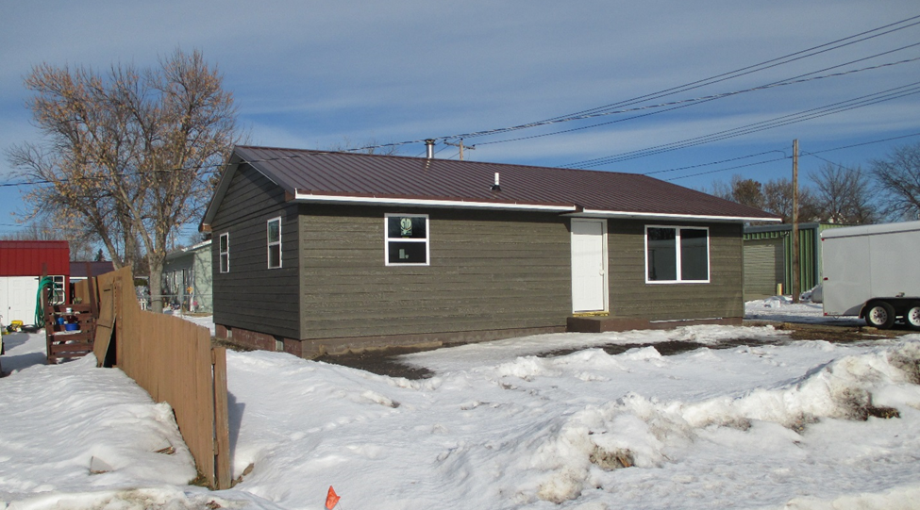
RECORD #6169

LOT SIZE 70’ X 85’ GROUND FLOOR 912 SQ FT
SINGLE FAMILY ONE STORY 3 BEDROOMS 1 ½ BATHS
AVERAGE QUALITY AND CONDITION BASEMENT 912 SQ FT
BUILT IN 1970 ROOFED PORCH 72 SQ FT
2014; ROOF POOR, SIDING POOR
BLOCK BSMT, WINDOWS POOR
SOLD ON 10/03/19 FOR $25,000
ASSESSED IN 2019 AT $71,970
ASSESSED IN 2012 AT $45,415 RECORD #6169

