$90,000.00
M & C RENTALS – GOSCH
1007 8TH AVE WEST, MOBRIDGE
MOBRIDGE NWTS CO’S 3RD ADDN LOT 4 & N ½ OF LOT 5 BLOCK 28
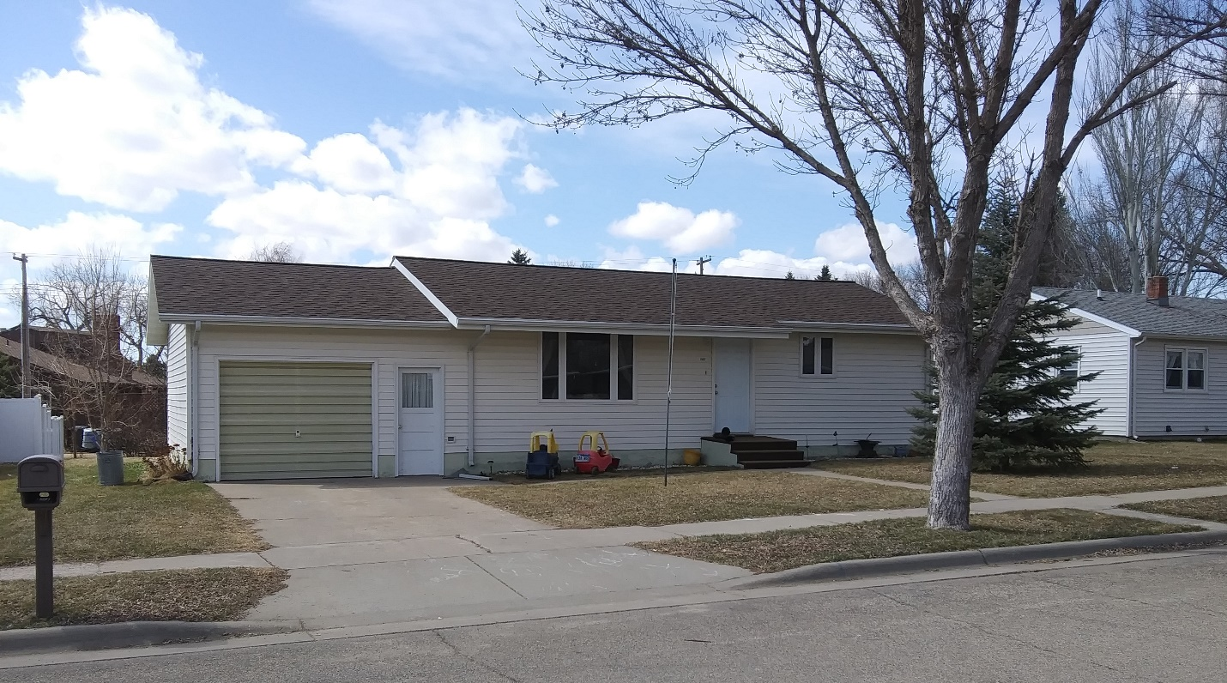
RECORD #6122

LOT SIZE 75’ X 120’ LIVING AREA 888 SQ FT
SINGLE FAMILY – ONE STORY NO BASEMENT
AVERAGE QUALITY & CONDITION 2 BEDROOMS
BUILT IN 1960 2 ½ BATHS
CENTRAL AIR – NATURAL GAS ATTACHED GARAGE 384 SQ FT
2014; ROOF GOOD, SIDING GOOD
2013; REPLACED ALL WINDOWS
SOLD ON 1/09/20 FOR $90,000
ASSESSED IN 2019 AT $78,010
SOLD 12/08/09 FOR $32,500
ASSESSED IN 2014 AT $41,405 RECORD #6122

