$87,000.00
LOTT – STREET
1115 1ST AVE WEST, MOBRIDGE
MOBRIDGE MAIN PARK S 25’ LOT 5 & N 25’ LOT 6 BLOCK 24
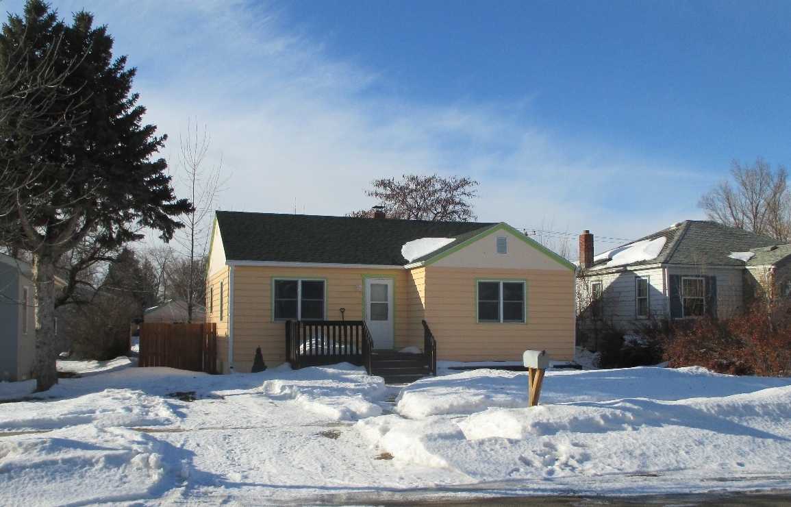
RECORD #5723

LOT SIZE 50’ X 142’ TOTAL LIVING AREA 843 SQ FT
SINGLE FAMILY – ONE STORY BASEMENT 843 SQ FT
FAIR QUALITY & CONDITION 2 BEDROOMS 1 ½ BATHS
BUILT IN 1950 DETACHED GARAGE 264 SQ FT
2014; MASONITE SIDING FAIR SOLID WALL PORCH 63 SQ FT
ALUMINUM WINDOWS FAIR
2013 NEW FURNACE
SOLD ON 9/19/19 FOR $87,000
ASSESSED IN 2019 AT $20,290
SOLD IN 2010 FOR $36,000
ASSESSED IN 2012 AT $35,391 RECORD #5723

