$233,500.00
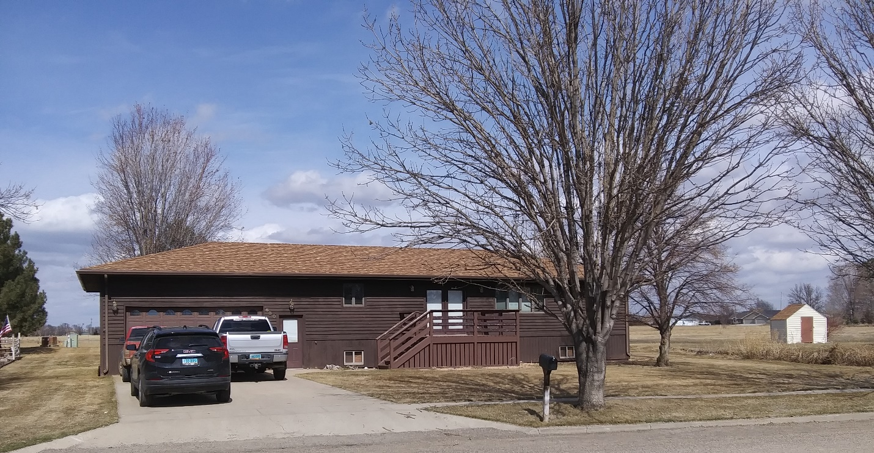
DIETTERLE – OSWALD
630 CRESCENT DR. MOBRIDGE
MOBRIDGE JAY-KRAFT 3RD ADDN LOT 17 &N 10’ OF LOT 18 BLOCK 4
RECORD #5551

LOT SIZE 92.6’ X 150 LIVING AREA 1288 SQ FT
SINGLE FAMILY – ONE STORY 1288 SQ FT BSMT/1200 FIN.
AVERAGE QUALITY & CONDITION 4 BEDROOMS - 3 ½ BATHS
BUILT IN 1995 24’ X 28’ ATTACHED GARAGE
2014; ROOF GOOD, WINDOWS GOOD 8’ X 8’ WOOD DECK REAR
NATURAL GAS - CENTRAL AIR 10’ X 12’ WOOD DECK FRONT
SOLD ON 2/04/2020 FOR $233,500 CEDAR SIDING
ASSESSED IN 2019 AT $172,670 10’ X 12’ UTILITY SHED
SOLD 12/13/11 FOR $173,000
ASSESSED IN 2011 AT $146,555
SOLD 1/05/06 FOR $155,000
ASSESSED IN 2006 AT $140,910 RECORD #5551

