$105,000.00
KIENHOLZ/SCHWAN – SELZLER
716 2ND AVE WEST, MOBRIDGE
MOBRIDGE GRAND CROSSING ADDN LOT 11 BLOCK 57
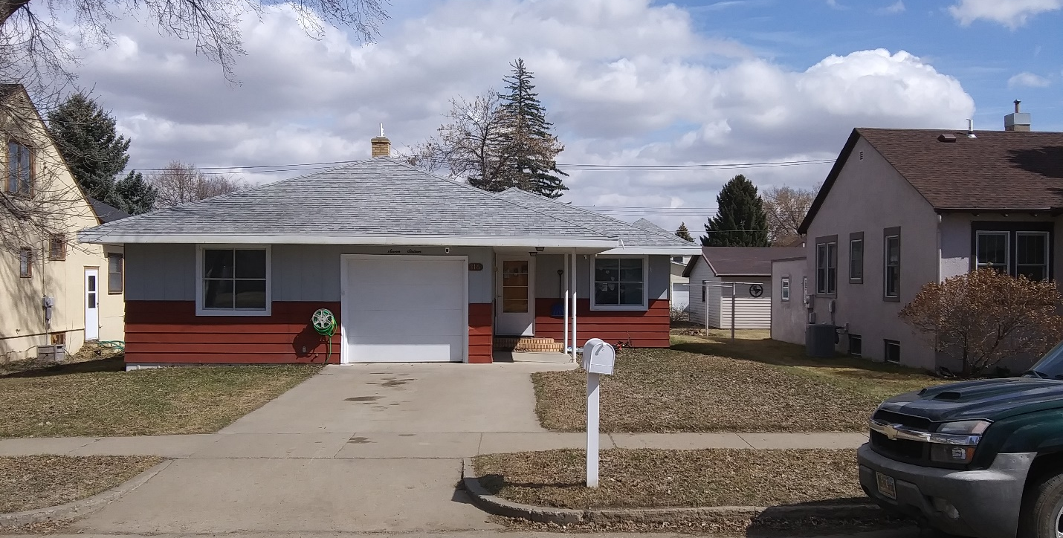
RECORD #5440

LOT SIZE 50’ X 140’ GROUND FLOOR 1209 SQ FT
ONE STORY – SINGLE FAMILY 2 BEDROOMS
AVERAGE QUALITY & CONDITION 1 ½ BATHS
BUILT IN 1953 FINISHED BASEMENT 1209 SQ FT
2014; ROOF GOOD, ALUM. SIDING GOOD ROOFED PORCH 112 SQ FT
WINDOWS FAIR, CENTRAL AIR WOOD DECK 80 SQ FT
1999; SPRINKLER 1995; 24’X24’GARAGE DETACHED GARAGE 576 SQ FT
SOLD ON 10/20/19 FOR $105,000 ATTACHED GARAGE 187 SQ FT
ASSESSED IN 2019 AT $82,450 2018; 6’ VINYL PRIVACY FENCE
SOLD 9/21/18 FOR $85,000
ASSESSED IN 2017 AT $50,010 RECORD #5440

