$35,000.00
OVERSETH – FAEHNRICH
417 3RD AVE WEST, MOBRIDGE
MOBRIDGE GRAND CROSSING ADDN LOT 2 BLOCK 29
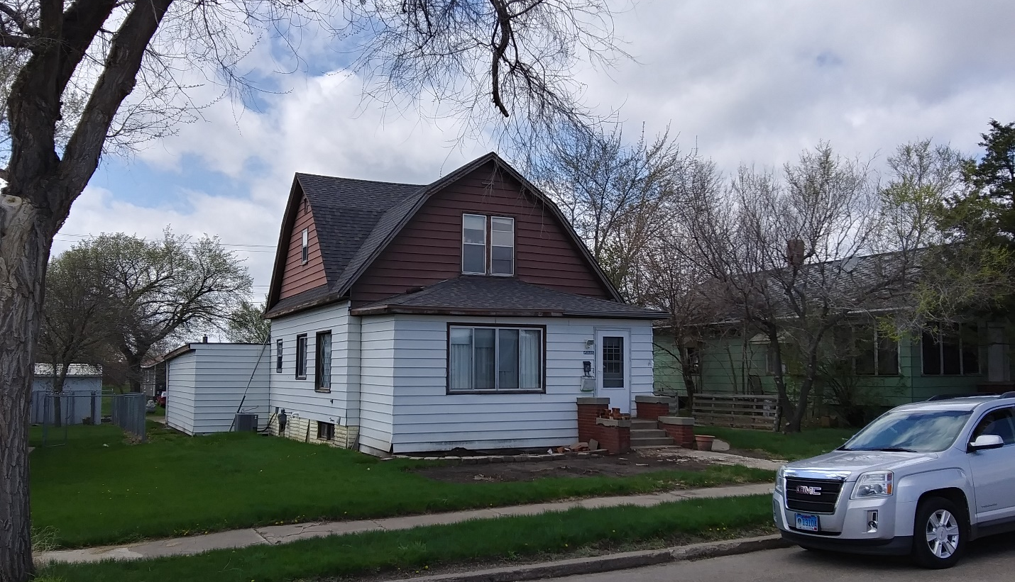
RECORD #5219

LOT SIZE 50’ X 140’ GROUND FLOOR 1407 SQ FT
SINGLE FAMILY – 1 ½ STORY TOTAL AREA 1950 SQ FT
WORN CONDITION 3 BEDROOMS - 1 ½ BATHS
AVERAGE QUALITY BASEMENT 775 SQ FT
BUILT IN 1930 ATTACHED GARAGE 448 SQ FT
2014; ROOF POOR, STEEL SIDING CENTRAL AIR – NATURAL GAS
WINDOWS POOR
SOLD ON 3/06/20 FOR $35,000
ASSESSED IN 2020 AT $37,560
ASSESSED IN 2016 AT $14,635

