$132,000.00
OSTER – JOBIN
510 6TH AVE. EAST, MOBRIDGE
MOBRIDGE FAIRVIEW ADDN LOTS 14 & 15 BLOCK 26
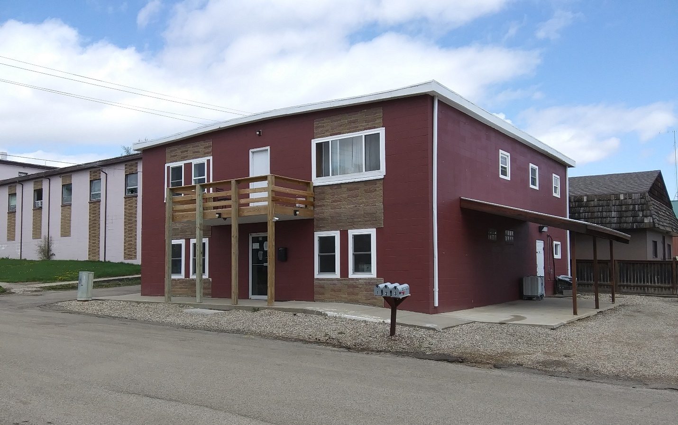
RECORD #5152

LOT SIZE 50’ X 140’ TOTAL AREA 3600 SQ FT
FAIR CONDITION & QUALITY GROUND FLOOR 3 BEDROOMS
BUILT IN 1960 + -
2007; MOVE INTERIOR WALL $1,000
2010; CLOSE 2 SIDES & WINDOWS $1,500
2011; REMODEL $10,000
2018; REPLACE DECK & WINDOWS $1,000
SOLD ON 4/01/20 FOR $132,000
ASSESSED IN 2020 AT $53,735
SOLD 9/01/2018 FOR $110,000; SOLD IN 2008 FOR $127,000

