$1,240,000.00
I-90 FUEL SERVICES INC. – HOLIDAY STATIONSTORES LLC
505 E GRAND CROSSING, MOBRIDGE
MOBRIDGE EKLO’S 1ST ADDN LOTS 10, 11 & 12 BLOCK 1
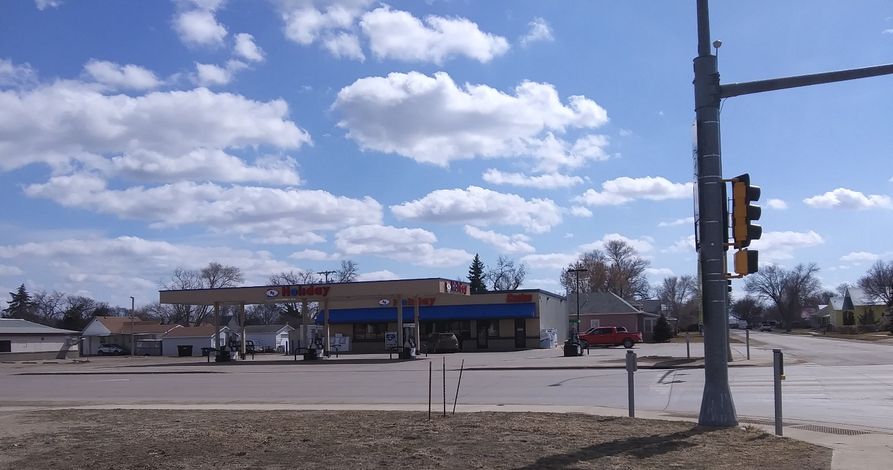
RECORD #4889

LOT SIZE 140’ X 150’
100% COMMERCIAL
MINI – MART CONVENIENCE STORE
GAS STATION
BUILT IN 2016
BUILDING PERMIT 12/07/2015 FOR $620,000
BUILT BY GIL HAUGAN CONSTRUCTION INC.

RECORD #4889

