$12,000.00
STANGL – SILBERNAGEL
907 2ND AVE EAST, MOBRIDGE
MOBRIDGE DRAEGER’S 1ST ADDN W 90’ OF LOTS 4, 5 & 6 BLOCK 16
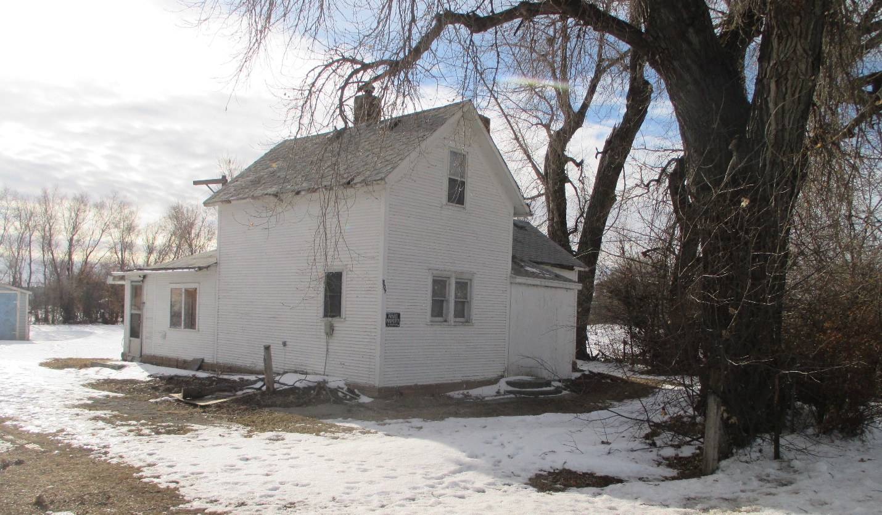
RECORD #4864

LOT SIZE 90’ X 150’ TOTAL LIVING AREA 1068 SQ FT
SINGLE FAMILY 1 ½ STORY GROUND FLOOR 936 SQ FT
BADLY WORN 4 BEDROOMS 1 BATH
BUILT IN 1900 + - DETACHED GARAGE 336 SQ FT
2014; SIDING POOR
SOME WINDOWS BOARDED
SOLD ON 7/22/19 FOR $12,000
ASSESSED IN 2019 AT $13,160
ASSESSED IN 2012 $10,580 RECORD #4864

