$37,000.00
STOICK – LEMBURG
4802 LINCOLN AVE. SELBY
SELBY OVERHOLSERS ADDN LOT 5 BLOCK 2
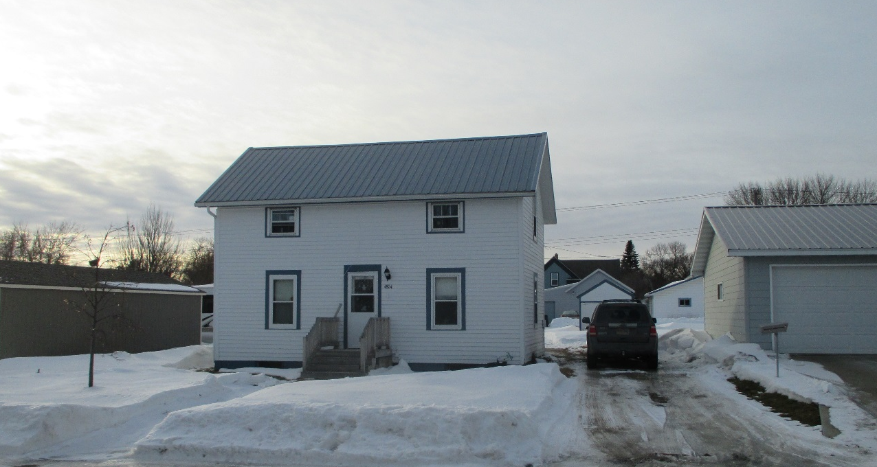
RECORD #4543

LOT SIZE 50’ X 140’ GROUND FLOOR 724 SQ FT
ONE STORY – SINGLE FAMILY TOTAL LIVING AREA 1127 SQ FT
AVERAGE QUALITY & CONDITION 3 BEDROOMS 1 ½ BATHS
BUILT IN 1910 BASEMENT 504 SQ FT
CENTRAL AIR – NATURAL GS WOOD DECK 392 SQ FT
1999; REMODEL, UPKEEP DETACHED GARAGE 200 SQ FT
2015; METAL ROOF, WOOD LAP SIDING FAIR
ALUM/WOOD WINDOWS
SOLD ON 11/8/19 FOR $37,000
ASSESSED IN 2019 AT $29,500
ASSESSED IN 2015 AT $16,605 RECORD #4543

