$15,500.00
ALLMENDINGER – WILLEY
5210 5TH AVE. SELBY
SELBY MILWUKEE LAND CO’S 2ND ADDN E 93.4’ OF LOT 1 & E 93.4 OF N 30’ LOT 2 BLOCK 26
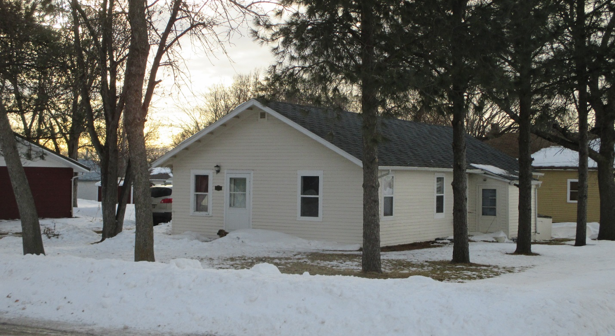
RECORD #4344

LOT SIZE 80’ X 93.4’ GROUND FLOOR 912 SQ FT
SINGLE FAMILY & ONE-STORY BASEMENT – CRAWL SPACE
AVERAGE QUALITY & CONDITION 2 BEDROOMS 1 BATH
CENTRAL AIR – NATURAL GAS 5 FIXTURES
BUILT IN 1910 ATTACHED GARAGE 264 SQ FT
2015; ROOF GOOD, WOOD LAP POOR
2018; NEW WINDOWS, 2012; RESHINGLED
SOLD ON 10/16/19 FOR $15,500
ASSESSED IN 2019 AT $18,340 RECORD #4344
SOLD IN 2016 FOR $15,000
ASSESSED IN 2016 AT $18,340, IN 2012 $6,610
SOLD IN 2013 FOR $17,500, IN 2009 FOR $11,000

