$10,000.00
BERMEL – PERKINS
7201 MINNEAPOLIS ST, JAVA
JAVA MILW LAND CO’S 1ST ADDN LOT 1 & N ½ LOT 2 BLOCK 7
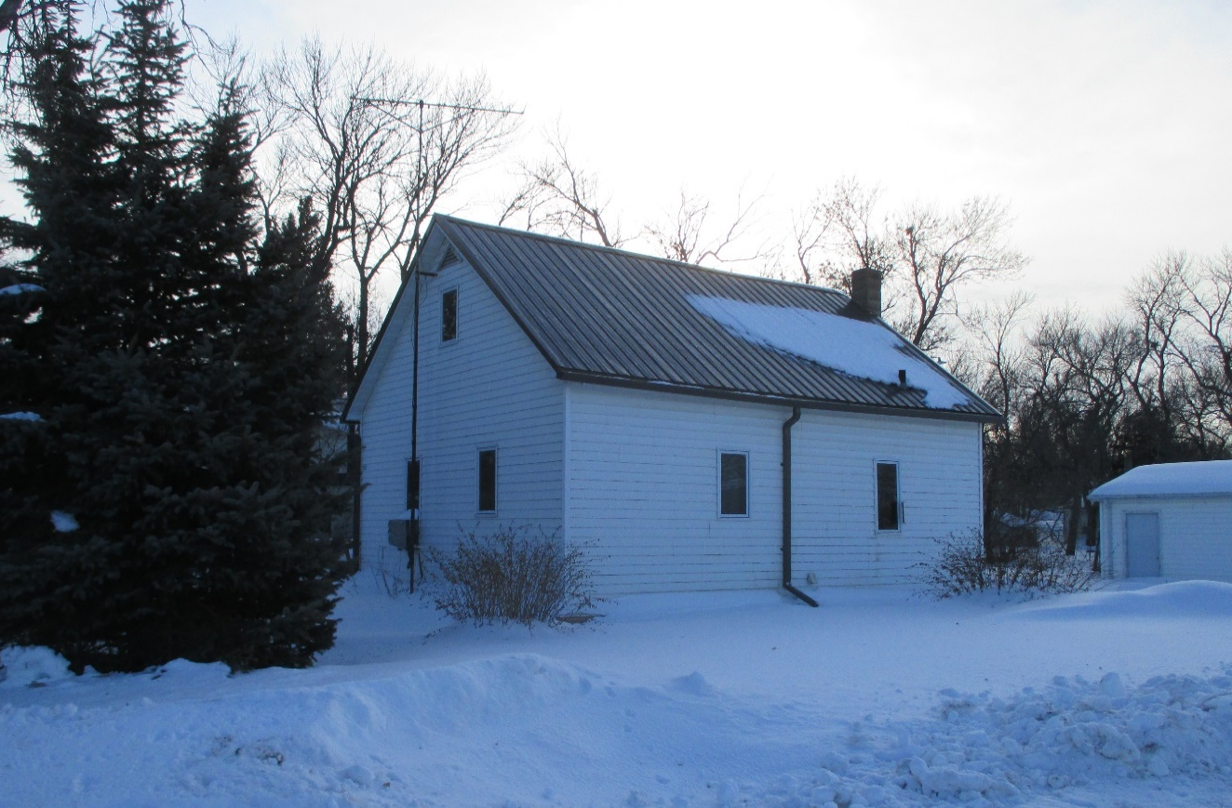
RECORD #4035
LOT SIZE 75’ X 140’ TOTAL LIVING AREA 1404 SQ FT
SINGLE FAMILY 1 ½ SORY SOLID WALL PORCH 77 SQ FT
WORN CONDITION & QUALITY WOOD DECK 187 SQ FT
BUIL IN 1920 1 BATH
2013; METAL ROOF DETACHED GARAGE 338 SQ FT
1988; RESIDED VINYL SIDING
SOLD ON 9/23/19 FOR $10,000
ASSESSED IN 2019 AT $7,970
ASSESSED IN 2015 AT $7,245 RECORD #4035 SQ FT

