$100,000.00
WALTH – HOLMBERG FAMILY TRUST
LOT 8 GOETZ ADDN IN S2SE4 21-124-79
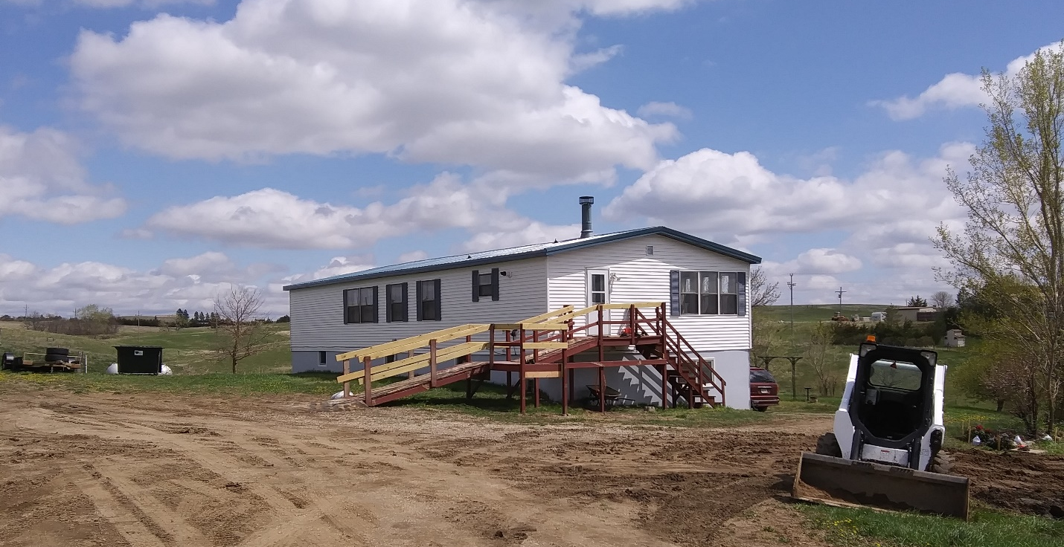
RECORD #3668

2.53 ACRES MAIN FLOOR 1742 SQ FT
SPLIT LEVEL BASEMENT 1066 SQ FT
MH 1991 26’ X 70’ FRIENDSHIP 2 BEDROOMS 2 BATHS
FAIR CONDITION GARAGE 676 SQ FT
2 CAR TUCK UNDER GARAGE WOOD DECK 120 SQ FT
WALK OUT BASEMENT SEVERAL WOOD SHEDS
CENTRAL AIR – NATURAL GAS
WOOD BURNER, VINYL SIDING
1990; DOUBLE WIDE ON BASEMENT $48,000
SOLD ON 2/16/20 FOR $100,000
ASSESSED IN 2020 AT $87,080
ASSESSED IN 2015 AT $76,380 RECORD #3668

