$40,000.00
KUMBAYA – WHARTON
111 8TH ST EAST, MOBRIDGE
MOBRIDGE GRAND CROSSING ADDN E 50’ OF LOT 18 BLOCK 59
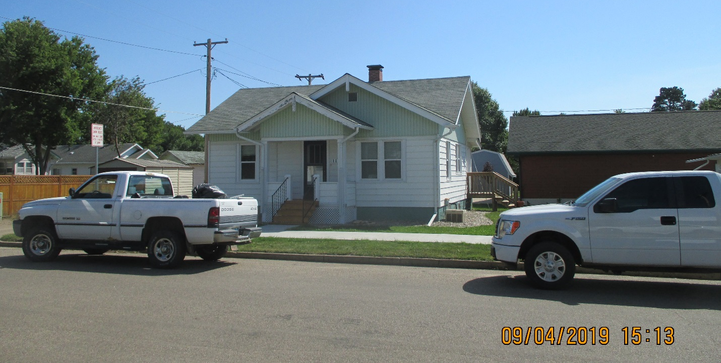
RECORFD #8533

LOT SIZE 50’ X 52’ TOTAL LIVING AREA 725 SQ FT
SINGLE FAMILY ONE STORY 2 BEDROOMS 1 ½ BATHS
AVERGAGE CONDITION & QUALITY BASEMENT 725 SQ FT
BUILT IN 1925 CARPORT 216 SQ FT
2015; CENTRAL AIR, VINYL SIDING SMALL WOOD PORCH 77 SQ FT
POURED FOUNDATION GOOD COVERED PORCH 40 SQ FT
SOLD ON 5/14/19 FOR $40,000
ASSESSED IN 2019 AT $30,470
ASSESSED IN 2014 AT $15,270 RECORD #8533

