$350,000.00
SCHLEPP – KEEGAN
12677 SD HWY 1804, MOBRIDGE
N 483.23’ OF THE S 1317.47’ OF E 1043’ OF SE4 18-124-79
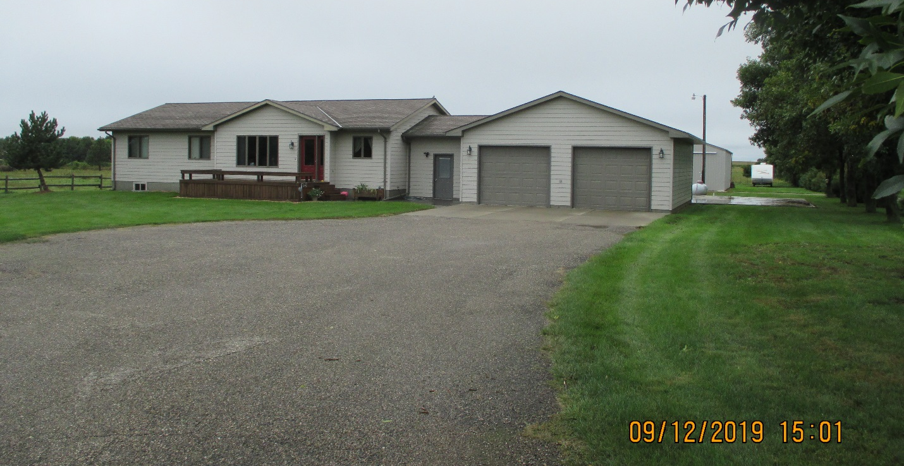
RECORD #7542

LOT SIZE 11.57 ACRES GROUND FLOOR 1554 SQ FT
SINGLE FAMILY ONE STORY 3 BEDROOMS 2 ½ BATHS
AVERAGE QUALITY & CONDITION 1554 SQ FT FINISHED BSMT
BUILT IN 1999 ATTACHED GARAGE 896 SQ FT
2015; ROOF GOOD, WOOD DECK EAST POLE BARN 40’ X 56’
WINDOWS IN BSMT BIG ENOUGH FOR EGRESS
2010; ROOF ON 16’X16’ DECK, 16’X24’ PATIO $15,000
2006; DETACHED GARAGE $14,000
SOLD ON 6/28/19 FOR $350,000 SOLID WALL PORCH 192 SQ FT
ASSESSED IN 2019 AT $271,150 WOOD DECK 144 SQ FT
SOLD ON 12/08/08 $240,000
ASSESSED IN 2012 AT $183,245 RECORD #7542

