$211,000.00
OLSON – JAGER
304 13TH ST WEST, MOBRIDGE
MOBRIDGE THOMPSON’S OUTLOTS E2 OF LOT 23
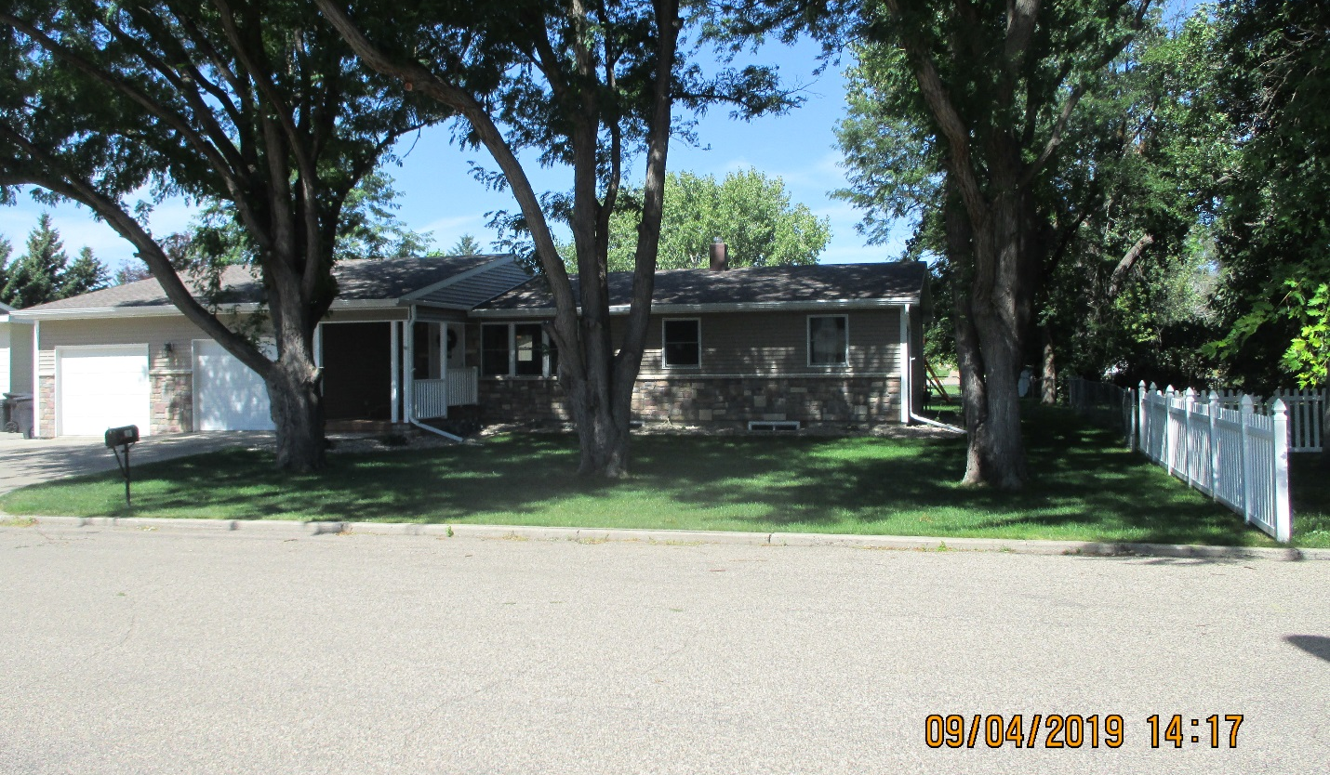
RECORD # 6509

LOT SIZE 82.5 X 264 TOTAL LIVING 1166 SQ FT
ONE STORY SINGLE FAMILY 3 BEDROOMS 1 ¾ BATHS
AVERAGE QUALITY & CONDITION 1166 SQ FT BASEMENT
BUILT IN 1965 600 SQ FT OF BSMT FINISHED
2009; R&R WALL IN GARAGE, GARAGE DOOR $1,000
2012; 13’X39’ GARAGE ADDITION $20,000 ATTACHED GARAGE 286 SQ FT
2015; ROOF GOOD, 3 EGRESS, CENTRAL AIR
DRIVE THRU ATTACHED GARAGE 2012; NEW VINYL SIDING WINDOWS
SOLD ON 3/29/19 FOR $211,000 OPEN SLAB PORCH 120 SQ FT
ASSESSED IN 2019 AT $166,240 ROOFED PORCH 84 SQ FT
SOLD IN 2014 FOR $170,000
ASSESSED IN 2014 AT $124,755 RECORD #6509

