$160,000.00
MALLOY – LLOYD
108 13TH ST EAST, MOBRIDGE
MOBRIDGE THOMPSON’S OUTLOTS, LOT 16B-1
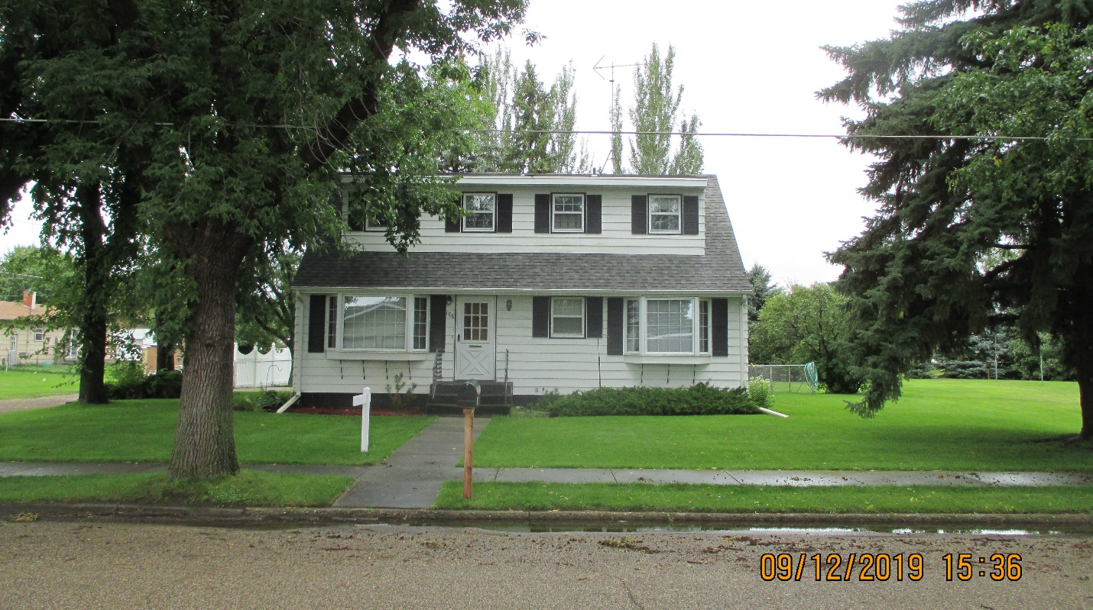
RECORD #6492

LOT SIZE 72.5’ X 132’ GROUND FLOOR 936 SQ FT
SINGLE FAMILY 1 ½ STORY TOTAL AREA 1404 SQ FT
AVERAGE QUALITY & CONDITION 2 BEDROOMS UPSTAIRS
BUILT IN 1950 1 BEDROOM GROUND FLOOR
2015; ROOF GOOD, LARGER DORMER SOUTH 1 ¾ BATHS
2 BOX BAYS SOUTH, METAL SIDING BASEMENT 936 SQ FT
VINYL/WOOD POOR, CENTRAL AIR 500 SQ FT FIN REC IN BSMT
DETACHED GARAGE ROOF GOOD 2 STALL DETACHED GARAGE
SOLD ON 6/07/2019 FOR $160,000 50’ X 20’ CEMENT SLAB
ASSESSED IN 2019 AT $105,170 8’ X 10’ UTILITY SHED
ASSESSED IN 2015 AT $56,665 RECORD #6492

