$117,500.00
CLAYMORE – BUCHY
310 12TH ST WEST, MOBRIDGE
MOBRIDGE THOMPSON OUTLOTS LOT 2A & 2F
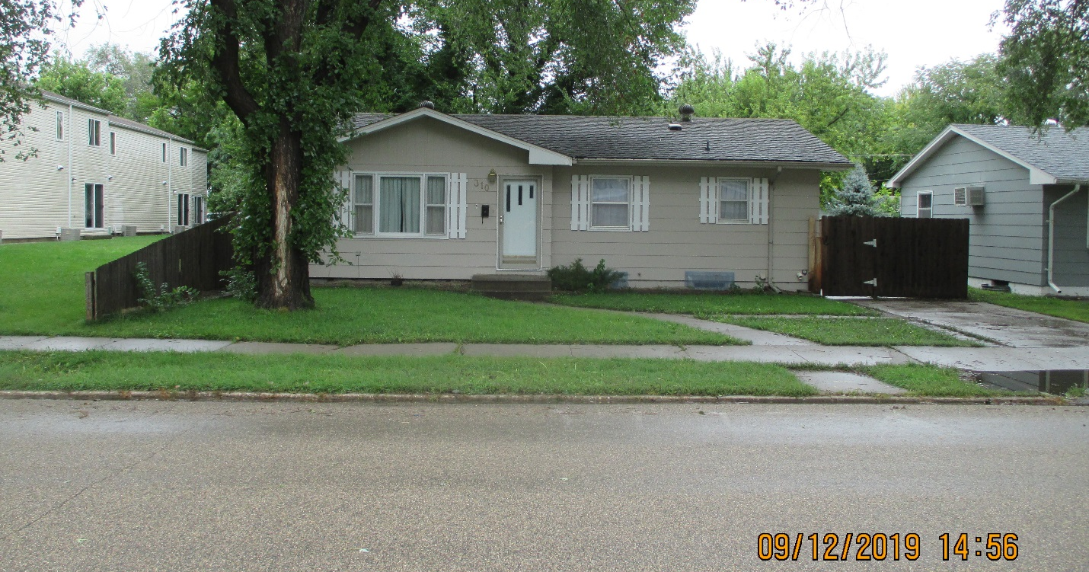
RECORD #6447

LOT SIZE 55’ X 244’ GROUND FLOOR AREA 1006 SQ FT
SINGLE FAMILY ONE STORY 1006 SQ FT BSMT/400 FT FINISHED
AVERAGE QUALITY & CONDITION 1 BATH
BUILT IN 1960 2002 REMODEL BASEMENT $6,000
2015; ROOF POOR, MASONITE 26’ X 58’ DETACHED GARAGE
SLAB & PAVER PATIO EAST 2003 ADDN TO GARAGE $6,000
PAVER WALKWAY TO GARAGE 2002 26’ X 46 CONCRETE SLAB $2,500
CENTRAL AIR NATURAL GAS
SOLD ON 7/19/19 FOR $117,500
ASSESSED IN 2019 AT $110,490
SOLD IN 2013 FOR $118,000; IN 2012 $104,000 RECORD #6447
SOLD IN 2005 FOR $80,000
ASSESSED IN 2015 AT $116,315; IN 2012 AT $76,850

