$34,500.00
SCHLOMER – KRAFT
MOBRIDGE NWTS CO’S 3RD ADDN LOT 12 BLOCK 36
1019 8TH ST WEST, MOBRIDGE
MOBRIDGE NWTS CO’S 3RD ADDN LOT 12 BLOCK 36
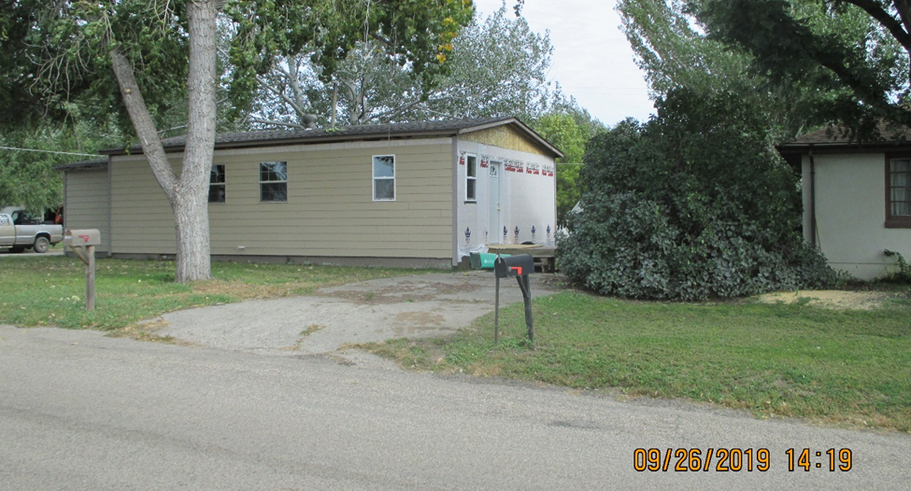
RECORD #6189

LOT SIZE 50’ X 120’ GROUND FLOOR 528 SQ FT
SINGLE FAMILY ONE STORY 1 BEDROOM 1 ½ BATHS
FAIR CONDITION & QUALITY BASEMENT 288 SQ FT
BUILT IN 1960 DETACHED GARAGE 288 SQ FT
2014; GOOD RIVER VIEW, ROOF POOR SOLID WALL PORCH 112 SQ FT
FASCIA POOR, NO GUTTERS
ALUM/WOOD WINDOWS FAIR
CENTRAL AIR, PROPANE
SOLD ON 8/20/19 FOR $34,500
ASSESSED IN 2019 AT $30,580
ASSESSED IN 2012 AT $15,645 RECORD #6189

