$19,000.00
SEIDEL – NISBET
1108 9TH AVE WEST, MOBRIDGE
MOBRIDGE NWTS CO’S 3RD ADDN LOTS 9 & 10 BLOCK 25
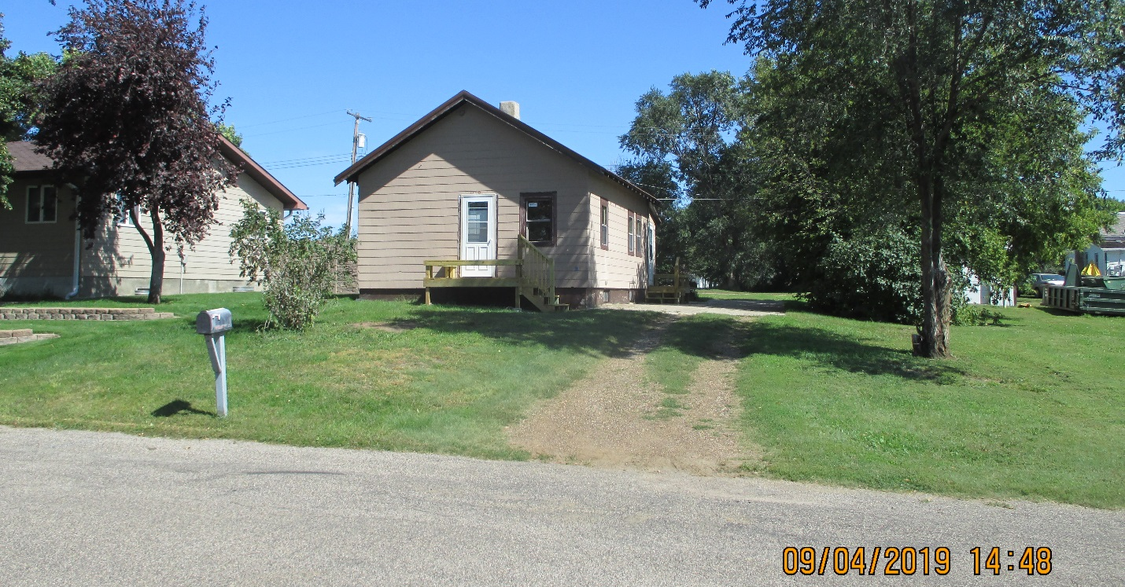
RECORD #6105

LOT SIZE 100’ X 120’ TOTAL LIVING AREA 760 SQ FT
ONE – STORY SINGLE – FAMILY 1 BEDROOM 1 BATH
POOR QUALITY & CONDITION BASEMENT 660 SQ FT
BUILT IN 1910 DETACHED GARAGE 14’ X 24’
1961 NEW BASEMENT; 1995 INTERIOR REMODEL
2004 REPAIR BSMT WALLS $2500
14’ X 24’ GARAGE $2,500
2012 REPLACE SHINGLES, 2014 METAL ROOF
SOLD ON 4/04/19 FOR $19,000
ASSESSED IN 2019 AT $18,9000 RECORD #6105
ASSESSED IN 2012 AT $17,380

