$138,000.00
HARE – ARTZ
812 8TH AVE WEST, MOBRIDGE
MOBRIDGE NWTS CO’S 2ND ADDN N 17’ OF LOT 10 & ALL OF LOT 11 BLOCK 24
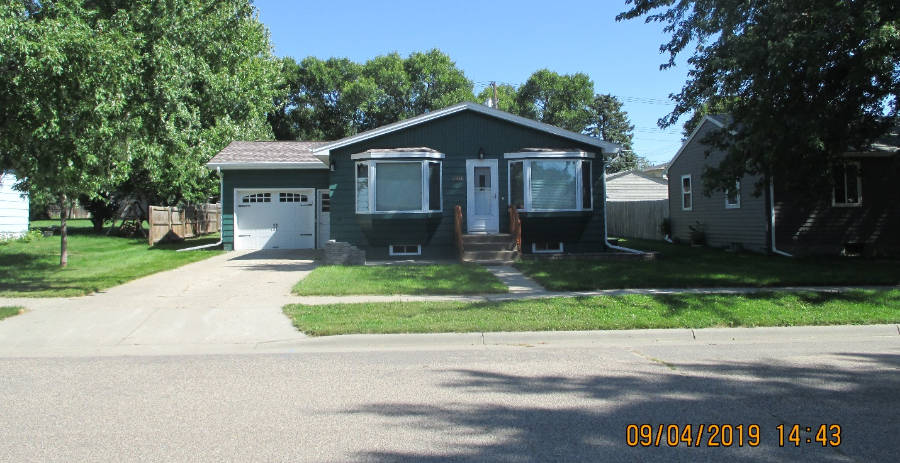
RECORD #6096

LOT SIZE 60’ X 140’ GROUND FLOOR 1092 SQ FT
SINGLE FAMILY ONE STORY 3 BEDROOMS 2 BATHS
AVERAGE QUALITY & CONDITION BASEMENT 1092 SQ FT, 819’ FIN. REC.
BUILT IN 1970 ATTACHED GARAGE 336 SQ FT
2014; SHINGLES GOOD, BLOCK FOUNDATION WOOD DECK 240 SQ FT
NEWER WINDOWS, CENTRAL AIR NATURAL GAS 8’ X 10’ SHED
2017; 2 EGRESS WINDOWS
SOLD ON 5/24/19 FOR $138,000 RECORD #6096
ASSESSED IN 2019 AT $120,950
SOLD IN 2017 FOR $120,000; SOLD IN 2007 FOR $54,600
ASSESSED IN 2016 AT $120,950; ASSESSED IN 2012 AT $57,125

