$134,000.00
PLATINUM TEMPORARY HOUSING LLC – ALLEN
906 8TH AVE WEST, MOBRIDGE
NWTS 2ND ADDN N 25’ OF LOT 9 & ALL LOT 10 BLOCK 23
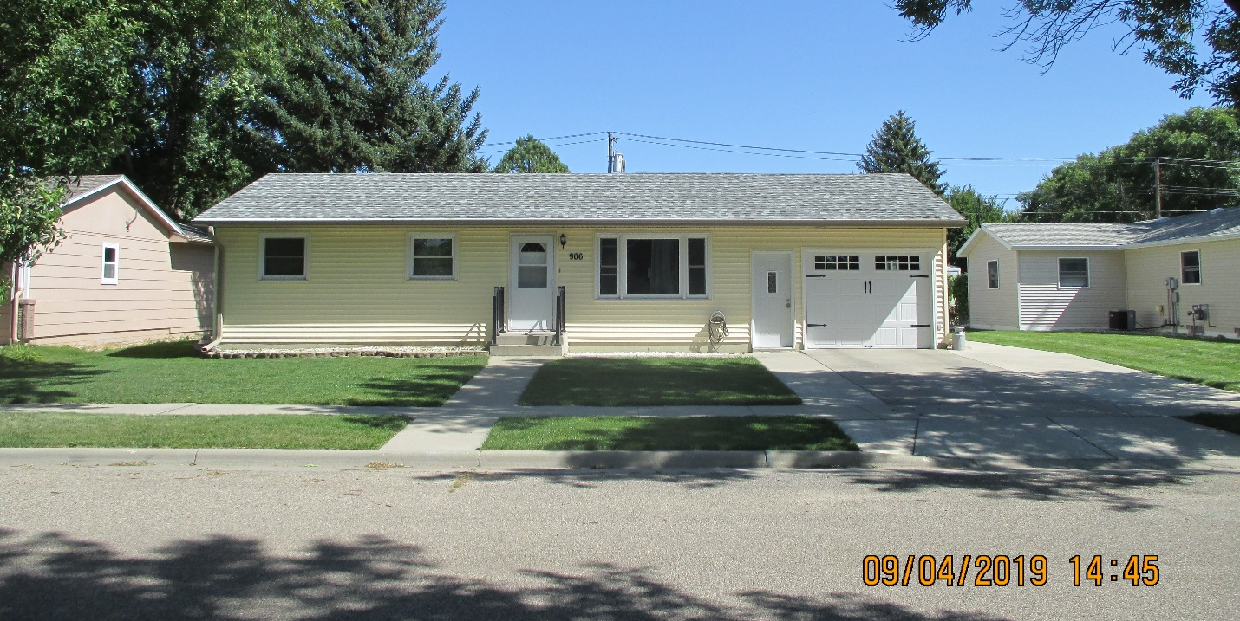
RECORD #6086

LOT SIZE 68’ X 140’ TOTAL LIVING AREA 988 SQ FT
SINGLE-FAMILY ONE-STORY BASEMENT 988 SQ FT; 700 SQ FT FIN.
AVERAGE QUALITY & CONDITION 1 BEDROOM ABOVE 2 BELOW
CENTRAL AIR HEAT PUMP 2 FULL BATHS
BILT IN 1970 2014; EGRESS WINDOW $2,085
SOLD ON 5/21/19 FOR $134,000 2006; ADDN. ATTACH. GARAGE
ASSESSED IN 2019 AT $144,220 576 SQ FT & COVERED PORCH.
SOLD IN 2015 FOR $140,000 ATTACHED GARAGE 364 SQ FT
ASSESSED IN 2014 AT $108,785 UTILITY SHED 10’ X 20’

RECORD #6086

