$103,000.00
GRENZ – OXNER
1022 6TH AVE WEST, MOBRIDGE
MOBRIDGE NWTS 1ST ADDN LOT 14 BLOCK 4
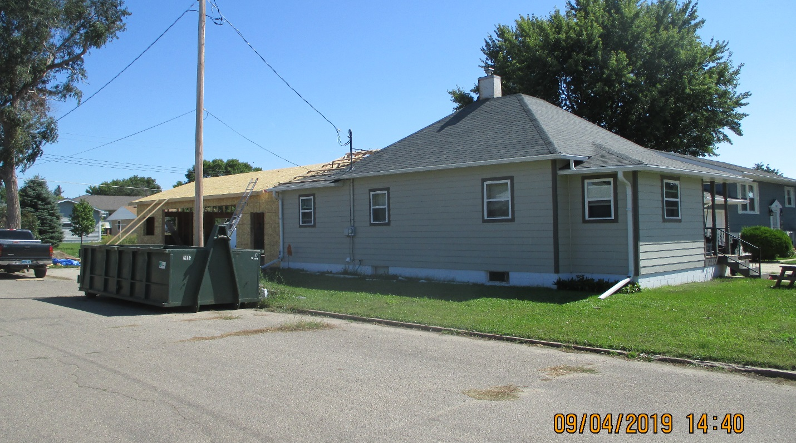
RECORD #5935

LOT SIZE 37.5’ X 140’ TOTAL LIVING AREA 990 SQ FT
SINGLE FAMILY ONE STORY 3 BEDROOMS 1 ½ BATHS
AVERAGE QUALITY & CONDITION 2 EGRESS WINDOWS
BUILT IN 1910 ATTACHED GARAGE 364 SQ FT
2015 – NEW PLUMBING, ½ NEW WIRING ROOFED PORCH 42 SQ FT
NEW KITCHEN, PUT ½ BATH IN BASEMENT
2 OTHER ROOMS IN BASEMENT COMPLETELY REMODELED
CENTRAL AIR
SOLD ON 12/07/2018 FOR $103,000 RECORD #5935
ASSESSED IN 2019 AT $86,220
SOLD IN 2015 FOR $91,000 ASSESSED IN 2016 AT $23,290

