$72,500.00
BURNS – GILBERT
309 2ND AVE WEST, MOBRIDGE
MOBRIDGE – MILW LAND CO’S 1ST ADDN LOT 4 BLOCK 25
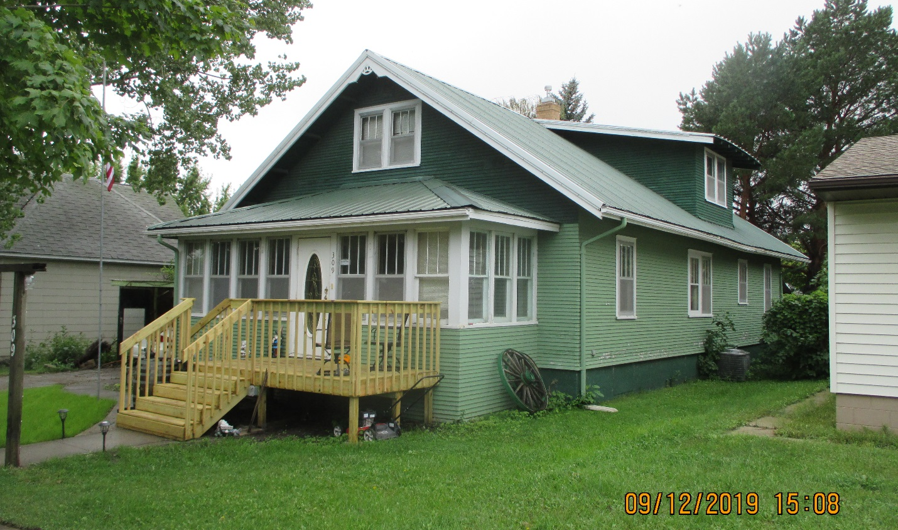
RECORD #5838

LOT SIZE 50’ X 140’ GROUND FLOOR 1344 SQ FT
SINGLE FAMILY - 1 ½ STORY TOTAL AREA 2036 SQ FT
AVERAGE QUALITY & CONDITION 4 BEDROOMS 2 ½ BATHS
BUILT IN 1924 BASEMENT 1344 SQ FT
2014; CENTRAL AIR, STEEL ROOF RECENT WOOD DECK IN FRONT
BASEMENT WINDOW BOARDED KNEE WALL PORCH 184 SQ FT
OLD SHIP LAP SIDING, DRIVEWAY POOR SOLID WALL PORCH 40 SQ FT
SOLD ON 6/25/19 FOR $72,500 CARPORT 240 SQ FT
ASSESSED IN 2019 AT $46,190 DETACHED GARAGE 798 SQ FT
ASSESSED IN 2012 AT $32,040

RECORD #5838

