$80,000.00
TALLEY – BIERMAN
313 2ND AVE WEST, MOBRIDGE
MOBRIDGE MILW LAND CO’S 1ST ADDN LOT 3 BLOCK 25
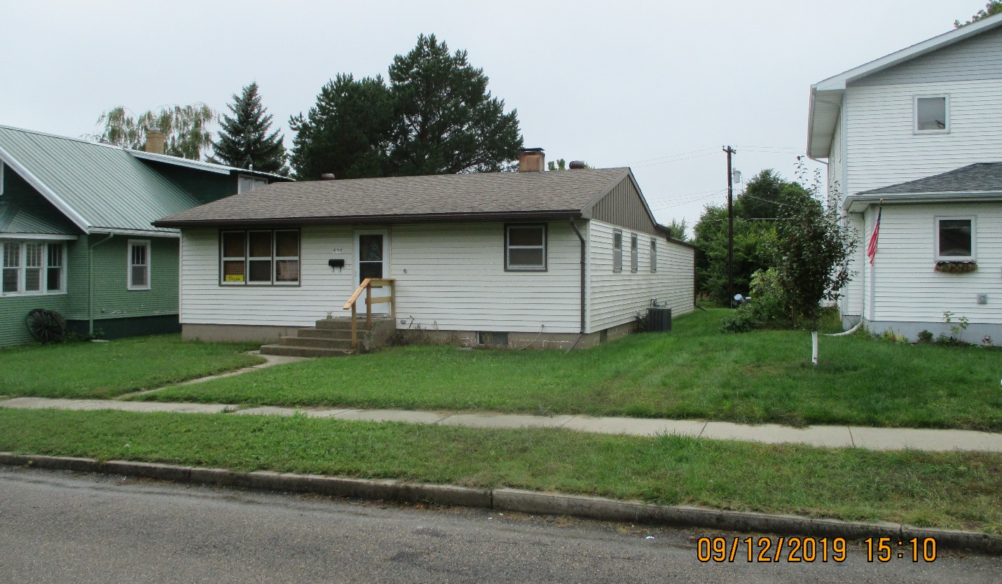
RECORD # 5837

LOT SIZE 50’ X 140’ GROUND FLOOR 1168 SQ FT
SINGLE FAMILY ONE STORY 2 BEDROOMS 1 ½ BATHS
AVERAGE QUALITY & CONDITION 2012 BSMT; ¾ BATH, REC ROOM $4000
BJUILT IN 1963 BSMT 1008 SQ FT FIN REC
2014; ROOF FAIR, VINYL SIDING ATTACHED GARAGE 520 SQ FT
CENTRAL AIR – NATURAL GAS
BLOCK BSMT SOME GLASS BLOCK WINDOWS
ALUM/METAL WINDOWS SOME OLD
CASEMENT WINDOWS POOR RECORD #5837
SOLD ON 7/16/19 FOR $80,000
ASSESSED IN 2019 AT $68,240
SOLD IN 2011 FOR $65,900; IN 2008 FOR$55,00; ASSESSED IN 2012 AT $33,020

