$65,000.00
KELLER-EISEMANN – KELLER
1108 2ND AVE WEST, MOBRIDGE
MOBRIDGE MAIN PARK N 20 ½ ‘ OF LOT 12 & ALL LOT 13 BLOCK 24
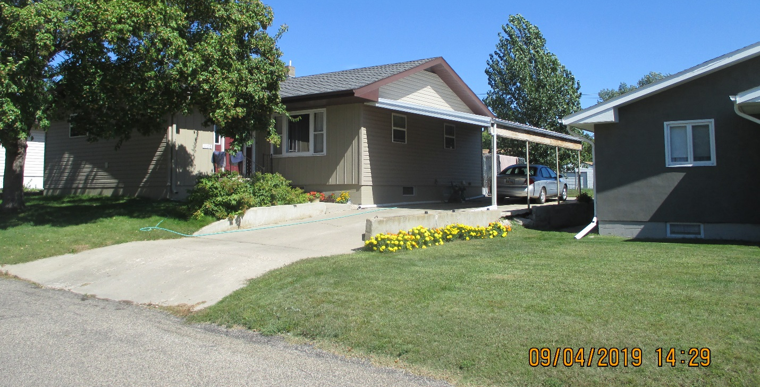
RECORD #5729

LOT SIZE 58’ X 142’ TOTAL LIVING 1384 SQ FT
SINGLE FAMILY ONE STORY 3 BEDROOMS 2 ½ BATHS
AVERAGE CONDITION & QUALITY BASEMENT 1272 SQ FT
BUILT IN 1965 400 SQ FT FIN. REC. IN BSMT.
2014; ROOF FAIR CARPORT 392 SQ FT
WOOD WINDOWS POOR SOLID WALL PORCH 531 SQ FT
NATURAL GAS CENTRAL AIR OPEN SLAB PORCH 531 SQ FT
2015; NEW SIDING, OUTSIDE REPAIRS
SOLD ON 4/04/2019 FOR $65,000
ASSESSED IN 2019 AT $38,160
SOLD ON 7/07/2015 $40,000 RECORD #5729
ASSESSED IN 2012 $70,545

