$37,000.00
DEKKER – GOLDSMITH
1005 NORTH MAIN, MOBRIDGE
MOBRIDGE MAIN PARK S 35’ OF LOT 6 & N ½ OF LOT 7 BLOCK 18
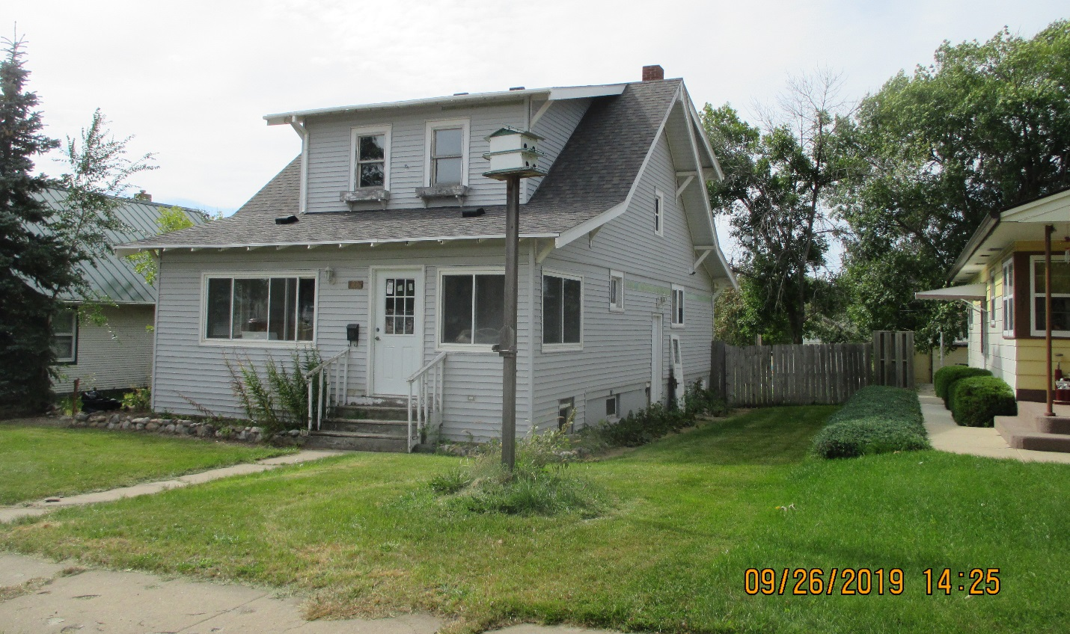
RECORD #5663

LOT SIZE 53.75’ X 152’ GROUND FLOOR 1080 SQ FT
SINGLE FAMILY 1 ½ STORY TOTAL AREA 1524 SQ FT
AVERAGE QUALITY & CONDITION 3 BEDROOMS 1 ¾ BATHS
BUILT IN 1930 BASEMENT 968 SQ FT
2014; VINYL SIDING, WINDOW AIR 484 SQ FT FINISHED REC BSMT
MIX OF OLD AND NEW WINDOWS SOLID WALL PORCH 192 SQ FT
SLIDING GLASS DOOR TO WEST WOOD DECK 80 SQ FT
SOLD ON 8/26/19 FOR $37,000 BSMT HAS OUTSIDE ENTRY
ASSESSED IN 2019 AT $69,310
SOLD IN 2001 FOR $51,800
ASSESSED IN 2014 AT $48,740 RECORD #5663

