$60,000.00
KLIMAS – WHARTON
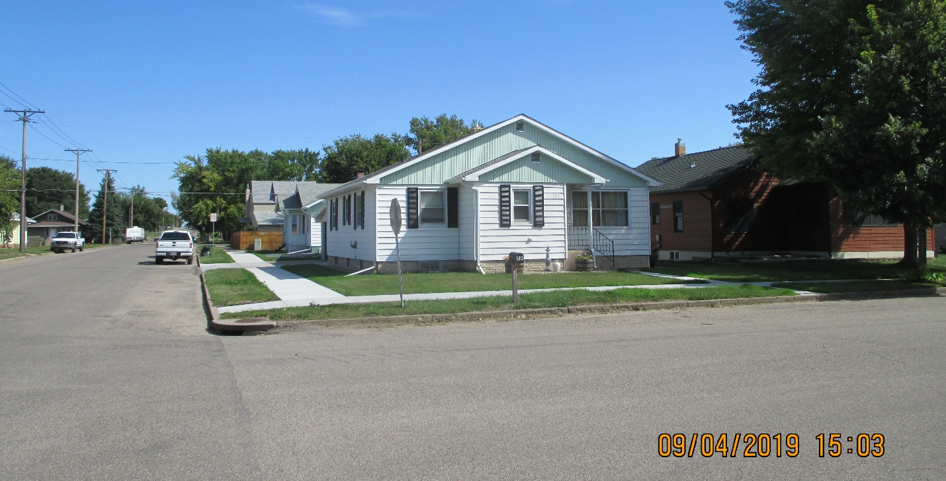
720 N. MAIN, MOBRIDGE
MOBRIDGE GRAND CROSSING ADDN W 102’ OF LOT 18 BLOCK 59
RECORD #5459

LOT SIZE 50’ X 100’ GROUND FLOOR 1225 SQ FT
SINGLE FAMILY ONE STORY 2 BEDROOMS 1 ½ BATHS
AVERAGE QUALITY & CONDITION FINISHED BASEMENT 1225 SQ FT
BUILT IN 1958 2 BEDROOMS 1 BATH IN BSMT.
2014; PORCH ROOF POOR, VINYL SIDING ATTACHED GARAGE 776 SQ FT
WINDOWS GOOD ROOFED PORCH 96 SQ FT
SOLD ON 2/21/19 FOR $60,000 SOLID WALL PORCH 55 SQ FT
ASSESSED IN 2019 AT $34,095
ASSESSED IN 2012 AT $29,495 RECORD #5459

