$273,060.00
KELLER – HARE
702 7TH ST WEST, MOBRIDGE
MOBRIDGE GRAND CROSSING ADDN. LOT 6 BLOCK 52
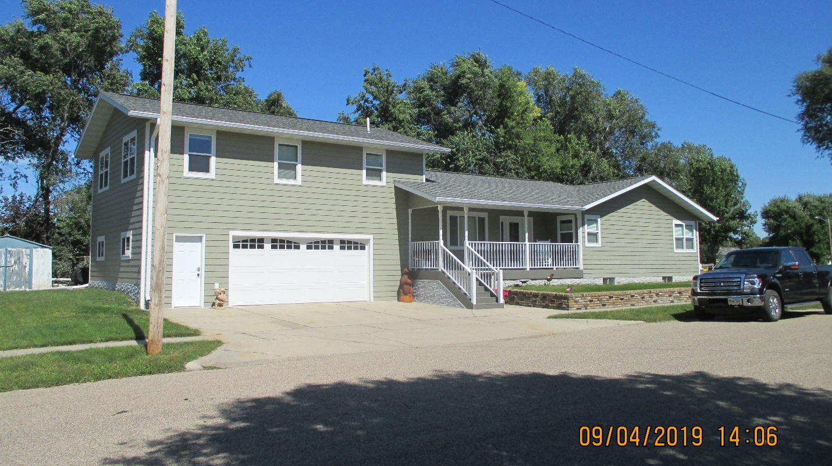
RECORD #5398

LOT SIZE 50’ X 140’ GROUND FLOOR 1150 SQ FT
1 ½ STORY SPLIT LEVEL TOTAL LIVING 1908 SQ FT
BUILT IN 1960 3 BEDROOMS PLUS ONE MASTER
AVERAGE QUALITY & CONDITION 2 BATHS
2014; ROOF GOOD, CENTRAL AIR, NATURAL GAS
COVERED SLAB PORCH, COVERED SLAB PATIO
CASEMENT WINDOW GOOD ROOFED PORCH 260 SQ FT
REMODEL ENTIRE HOME BASEMENT 1150 SQ FT
ADDITION ON TOP OF GARAGE ATTACHED GARAGE 768 SQ FT
SOLD ON 5/31/19 FOR $273,060 MASTER BEDROOM ABOVE GARAGE
ASSESSED IN 2019 AT $67,295
ASSESSED IN 2012 AT $58,270 RECORD #5398

