$130,000.00
BIALAS – FEES
400 WEST THEODORE
SELBY MILW. OUTLOTS, LOT A OUTLOT D LOTS 5 & 6
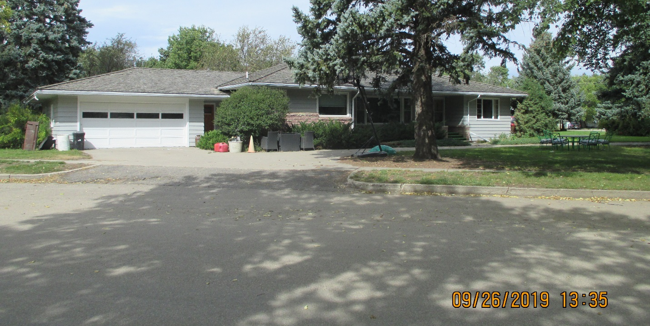
RECORD #4385

LOT SIZE 100’ X 140’ GROUND FLOOR 1679 SQ FT
SINGLE-FAMILY ONE-STORY BASEMENT 1679 SQ FT
AVERAGE QUALITY & CONDITION 1260 SQ FT FIN. REC IN BSMT
BUILT IN 1957 2 BEDROOMS ABOVE 2 BELOW
2015; ROOF FAIR, EGRESS NORTH & WEST 2 FULL BATHS ONE ½ BATH
COVERED FRONT & REAR STEPS GARAGE 699 SQ FT
CENTRAL AIR NATURAL GAS 2017 UPGRADE LAUNDRY &
SOLD ON 7/03/19 FOR $130,000 KITCHEN $25,000
ASSESSED IN 2019 AT $94,590
SOLD IN 2014 FOR $50,000
ASSESSED IN 2014 AT $54,515 RECORD #4385

