$281,000.00
KARY – CORN
111 NORTH RIVERVIEW DR., NEW EVARTS
LOT 31 IN REPLAT OF NW4 29-123-78
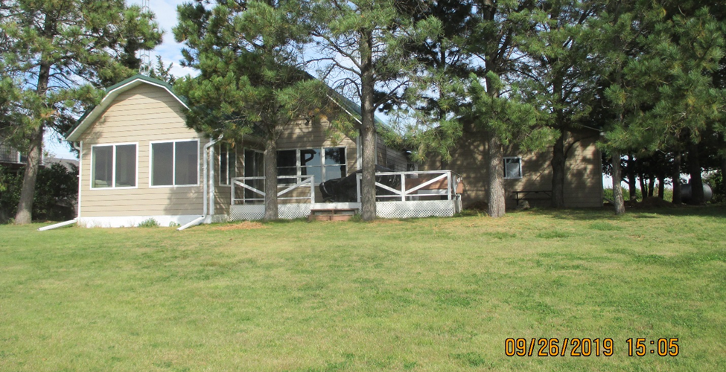
RECORD #2398

LOT SIZE 100’ X 200’ GROUND FLOOR 896 SQ FT
SINGLE FAMILY 1 ½ STORY EAST ADDITION 672 SQ FT
AVERAGE QUALITY & CONDITION SUN ROOM WEST 224 SQ FT
BUILT IN 1995 WOOD DECK 250 SQ FT
2007; 24’ X 28’ DETACHED GARAGE CENTRAL AIR
2014; SUN ROOM, MASTER BEDROOM $30,000
SOLD ON 8/23/19 FOR $281,000 WOOD SHED METAL ROOF
ASSESSED IN 2019 AT $200,500
ASSESSED IN 2015 AT $116,260

