$58,792.00
SCHERR – BEZENEK
LOT A SUBD TRACT 3 SCHIRBER ADDN IN W2NE4 13-124-80
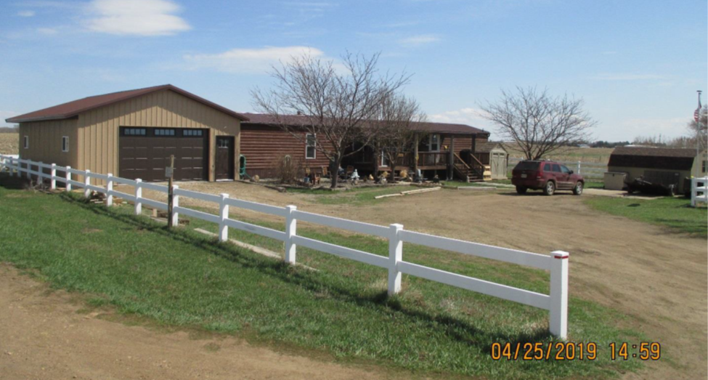
RECORD #8888

LOT SIZE .28 ACRES GROUND FLOOR 1340 SQ FT
ONE STORY MANUFACTURED HOME 2 BEDROOMS 2 BATHS
AVERAGE QUALITY & CONDITION 400 SQ FT WOOD DECK
BUILT IN 1960 MH SERIAL; NEB89A00812
WOOD SIDING TITILE #11205859
IN FLOOR HEAT IN ADDITION
2003; 26’X30’ ADDITION, 2004; 28’X50’ HORSE BARN
2007 20’X28’ ADDN TO BARN $10,000
1998 16’X80’ CHIEFTON MH
SOLD ON 1/2/2019 FOR $58,792
ASSESSED IN 2019 AT $43,400 RECORD #8888

