$70,000.00
MUSKE – RUPPERT
13788 315TH AVE
BIEBER OUTLOT A IN SW4 11-122-75
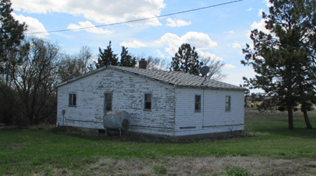
RECORD #7571

19.83 ACRES 60’ X 40’ SHED
2 HOUSES SINGLE FAMILY ONE STORY 56’ X 40’ SHED
FAIR QUALITY WORN CONDITION 26’ X 16’ SHED
DETACHED GARAGE 14’ X 12’ SEVERAL SMALLER BLDGS.

HOUSE #1
828 SQ FT LIVING AREA & BASEMENT HOUSE #2
1 BATH 1024 SQ FT
BUILT IN 1945 1BATH
FUEL OIL HEAT FURNACE
BUIL IN 1950
SOLD ON 8/28/2018 FOR $70,000
ASSESSED IN 2019 AT $81,735
SOLD IN 2016 FOR $87,000
ASSESSED IN 2015 AT $59,330 RECORD #7571
SOLD IN 2010 FOR $59,000
ASSESSED IN 2011 AT $51,590

