$255,000.00
KONOLD – KONOLD FAMILY RELATIONSHIP
1918 KENNEDY DRIVE, MOBRIDGE
MOBRIDGE SHOR ACRES LOT 94
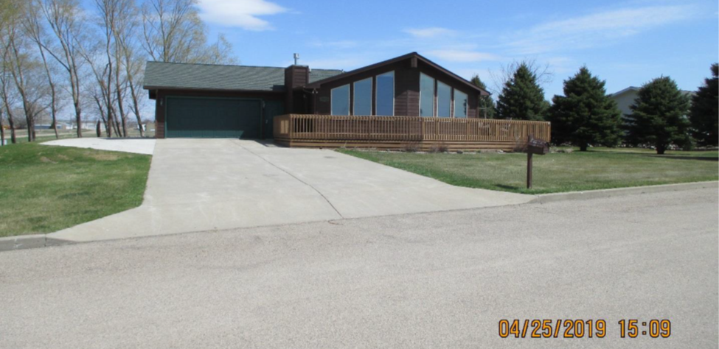
RECORD #6409

LOT SIZE 142.5’ X 120’ GROUND FLOOR LIVING 1405 SQ FT
SINGLE FAMILY – ONE STORY FINISHED BASEMENT 1325 SQ FT
AVERAGE QUALITY & CONDITION GARAGE FINISHED WITH SINK 744 SQ FT
BUILT IN 2001 WOOD DECK 563 SQ FT
CENTRAL AIR, WOOD SIDING, 2 EGRESS 2 ½ BATHS 2 BEDROOMS ABOVE
WOOD DECK, SLIDING GLASS DOOR 2 BEDROOMS BELOW
SOLD ON 2/6/2019 FOR $255,000 ATTACHED DRIVE THRU GARAGE
ASSESSED IN 2019 AT $232,680
SOLD IN 2016 FOR $205,000 FAMILY RELATIONSHIP SALE
SOLD IN 2005 FOR $187,500
ASSESSED IN 2012 $217,990 RECORD #6409

