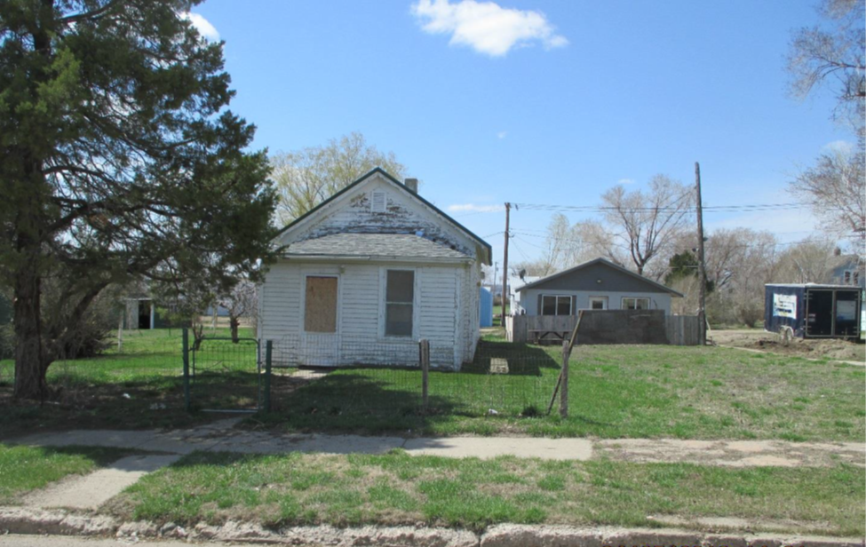
$5,000.00
HUMMEL-CHRISTMAN
211 1ST AVE. WEST, MOBRIDGE
MOBRIDGE ORIGINAL LOT 4 BLOCK 5
RECORDE #6264

LOT SIZE 50’ X 140’ TOTAL LIVING 645 SQ FT
SINGLE FAMILY-ONE STORY ONE BEDROOM ONE BATH
CONDITION BADLY WORN 16’X24’ WORN DETACHED GARAGE
BUILT IN 1920 SOLID WALL PORCH 120 SQ FT
2015; LAP SIDING POOR, ROOF FAIR BASEMENT 495 SQ FT
WINDOWS POOR, WINDOW AIR
SOLD ON 10/05/18 FOR $5,000
ASSESSED IN 2019 AT $10,900
ASSESSED IN 2014 AT $8,495 RECORD #6264

