$46,000.00
CARLA LANG ESTATE – HAUCK
221 4TH ST WEST, MOBRIDGE
MOBRIDGE ORIGINAL LOT 12 BLOCK 4
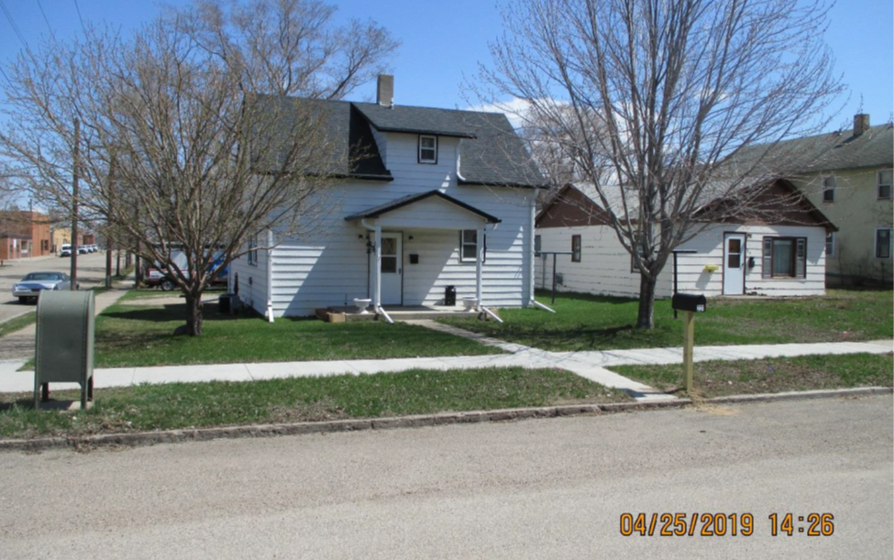
RECORD #6260

LOT SIZE 50’ X 140’ GROUND FLOOR 884 SQ FT
SINGLE FAMILY – 1 ½ STORY TOTAL LIVING 1284 SQ FT
AVERAGE QUALITY & CONDITION 3 BEDROOMS 1 ½ BATHS
BUILT IN 1927 ROOFED PORCH 78 SQ FT
CENTRAL AIR – NATURAL GAS WOOD DECK 104 SQ FT
2015; WINDOWS FAIR, ROOF GOOD
SOLD ON 11/9/18 FOR $46,000 RECORD #6260
ASSESSED IN 2019 AT $30,340 NOT ON OPEN MARKET
ASSESSED IN 2014 AT $18,520 SEQUENCE #’S 18-0354 & 0355

