$120,000.00
DECKERT-KRAFT
1102 4TH AVE WEST, MOBRIDGE
MOBRIDGE NWTS CO’S 2ND ADDN LOTS 9 & 10 & S 27’ OF LOT 11 BLOCK 17
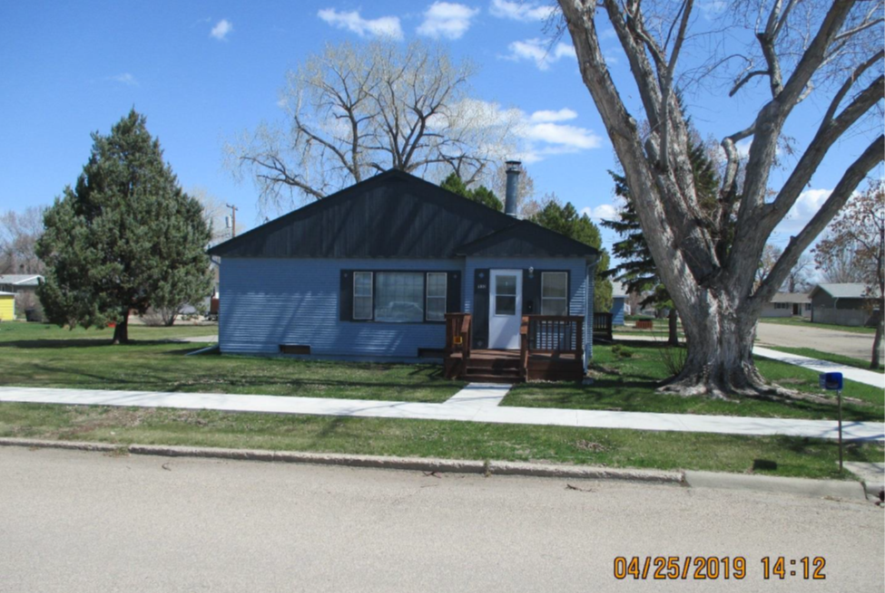
RECORD #6028

LOT SIZE 119’ X 140’ GROUND FLOOR 1608 SQ FT
SINGLE FAMILY ONE STORY 4 BEDROOMS
AVERAGE QUALITY & CONDITION 2 FULL BATHS
BUILT IN 1949 + - BASEMENT 1608 SQ FT
MOVED HOUSE ONTO BASEMENT IN 1962 1286 FINISHED REC. BSMT.
2014; LAP SIDING POOR, ROOF POOR ATTACHED GARAGE 660 SQ FT
OLDER WINDOWS POOR, SMALL SHED POOR SOLID WALL PORCH 260 SQ FT
SOLD ON 4/16/19 FOR $120,000 OPEN SLAB PORCH 670 SQ FT
ASSESSED IN 2019 AT $130,120 10’ X 12’ UTILITY SHED

