$65,000.00
KESSLER – JENSEN
708 9TH ST WEST, MOBRIDGE
MOBRIDGE NWTS CO’S 1ST ADDN W 75’ OF LOT 7 & 37.5’ OF W 75’ OF LOT 6 BLOCK 6
RECORD #5940
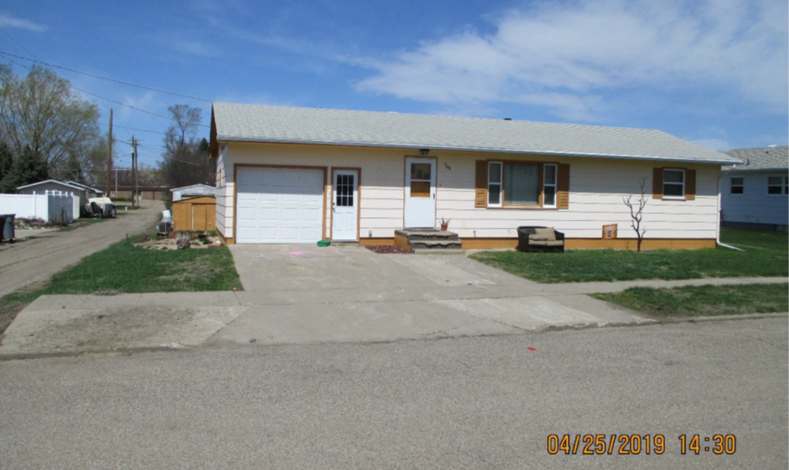
LOT SIZE 75’ X 75’ GROUND FLOOR 960 SQ FT
SINGLE FAMILY – ONE STORY FINISHED BASEMENT 960 SQ FT
AVERAGE QUALITY & CONDITION 2 BEDROOMS 1 ½ BATHS
BUILT IN 1950 7’ X 10’ UTILITY SHED
2014; SHINGLE ROOF GOOD, WINDOWS GOOD
MASONITE GOOD, CENTRAL AIR ATTACHED GARAGE 336 SQ FT
SOLD ON 9/4/18 FOR $65,000
ASSESSED IN 2019 AT $81,870
ASSESSED IN 2014 AT $49,265 RECORD #5940

