$200,000.00
VALLEY-STEIGER PROPERTIES
GRAND CROSSING, MOBRIDGE
MOBRIDGE GRAND CROSSING ADDN LOT 31 THRU 42 BLOCK 61
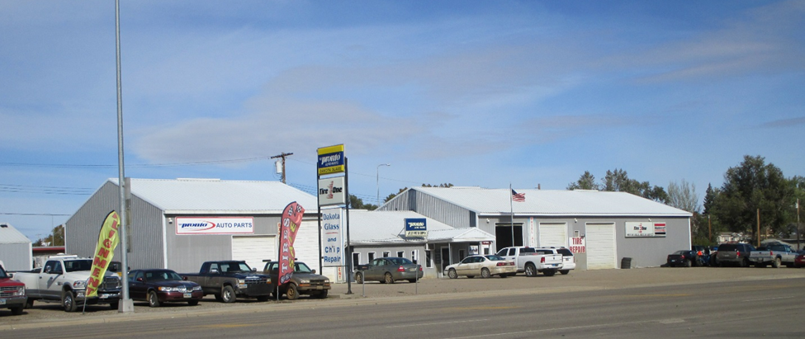
RECORD #5523

LOT SIZE 125’ X 113’ TOTAL AREA 7,172 SQ FT
SERVICE REPAIR GARAGE/RETAIL 100% COMMERCIAL
BUILT IN 1990 + - POLE FRAME
2005; 26’ X 40’ DETACHED GARAGE 1,040 SQ FT EQUIP. STORAGE
2003; ADDN TO GARAGE, PAVING
OTHER IMPROVEMENTS $40,000
2000 INSTALL 40’ DRIVEWAY $2,000
2003 44’ X 48’ ADDN
SOLD ON 9/28/18 FOR $200,000
ASSESSED IN 2018 $197,495
ASSESSED IN 2012 $144,850 RECORD #5523

