$63,000.00
KUMBAYA LLC – SILBERNAGEL
715 2ND AVE EAST, MOBRIDGE
MOBRIDGE GRAND CROSSING ADDN. LOT 3 BLOCK 60
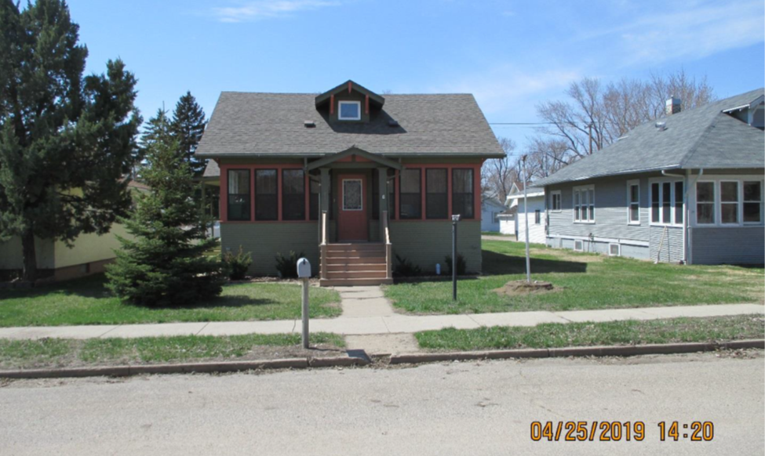
RECORD #5462

LOT SIZE 50’ X 140’ GROUND FLOOR 1164 SQ FT
ONE STORY-SINGLE FAMILY 3 BEDROOM 1 ½ BATH
AVERAGE QUALITY & CONDITION 1164 SQ FT BASEMENT
BUILT IN 1930 FINISHED BASEMENT
NATURAL GAS - CENTRAL AIR KNEE WALL PORCH 270 SQ FT
2009 REPLACE WINDOW WITH EGRESS
2014; LAP SIDING POOR, WINDOW TRIM POOR
SOLD ON 3/12/19 FOR $63,000
SOLD IN 2012 FOR $49,000 RECORD #5462
ASSESSED IN 2019 AT $62,900
ASSESSED IN 2012 AT $55,725

