$65,000.00
OXNER – LAZY TV RANCH
210 W DAKOTA ST. SELBY
SELBY PLAINVIEW 1ST, S 100’ OF LOT 8, S 25’ OF LOT 9 & ALL LOT 10 BLK 4
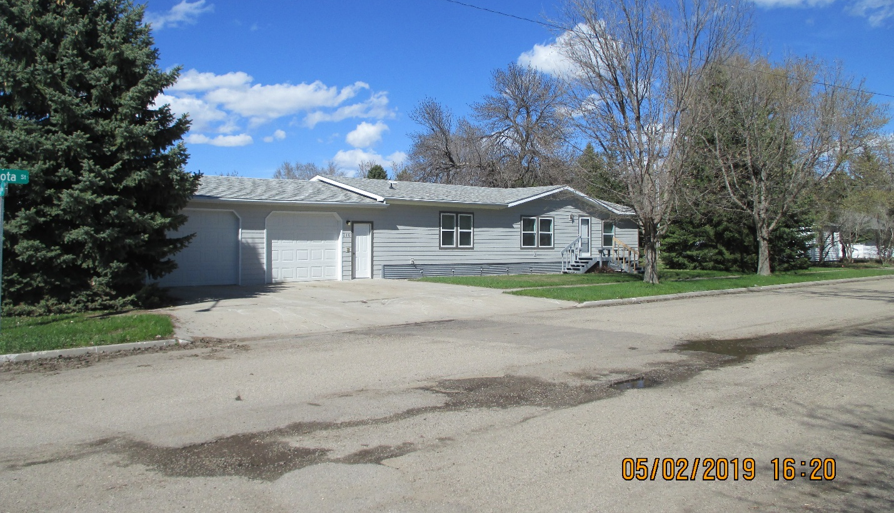
RECORD #4620

LOT SIZE 100’ X 140’ GROUND FLOOR 1596 SQ FT
ONE STORY – SINGLE FAMILY 3 BEDROOMS 2 BATHS
AVERAGE QUALITY & CODITION ATTACHED GARAGE 896 SQ FT
MANUFACTURED HOME
BUILT IN 1992 NEW SIDING AND MORE JUNE 2018
2015; VINYL SIDING, ROOF GOOD LANDSCAPING JUNE 2018
SMALL DECK SOUTH & NORTH- FRENCH DOOR
NO BASEMENT, CENTRAL AIR- NATURAL GAS
SOLD ON 11/15/19 FOR $65,000
ASSESSED IN 2019 AT $60,380
ASSESSED IN 2014 AT $57,780 RECORD #4620

