$60,500.00
HOLDER – SOLIOS AVILA
3503 3RD, SELBY
SELBY ORIGINAL N 35’ LOT 8 & ALL LOT 9 BLOCK 9
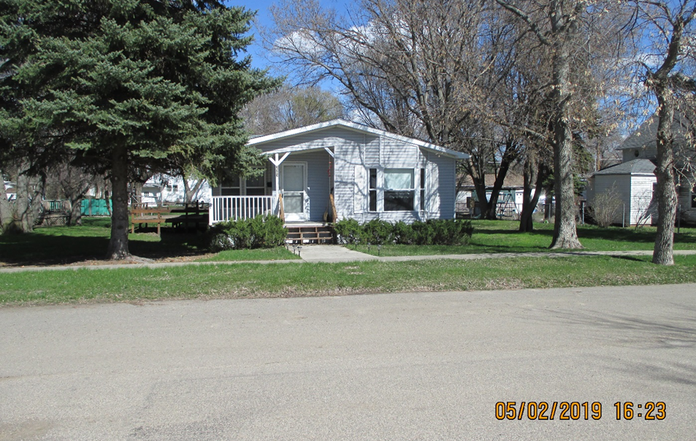
RECORD #4462

LOT SIZE 80’ X 140’ GROUND FLOOR 1344 SQ FT
MANUFACTURED HOME 2 BEDROOMS 1 ½ BATHS
1997 CHIEF 30’ X 60’ 192 SQ FT WOOD DECK
AVERAGE QUALITY & CONDITION ROOFED PORCH 84 SQ FT
2015; VINYL SIDING, BOW WINDOW WEST DETACHED GARAGE 624 SQ FT
COVERED FRONT DECK, SMALL WOOD SHED
NATURAL GAS, CENTRAL AIR
SOLD ON 1/10/19 FOR $60,500
ASSESSED IN 2019 AT $57,070
ASSESSED IN 2012 AT $45,140 RECORD #4462

